**Quarter 1 Project Report: Driver Liability Prediction Using Crash Data**

**Arjun Pagidi and Abhi Palikala**

## 

## 

## **Statement/Project Goal**

The goal of this project is to develop a machine learning model that predicts whether a driver was at fault in a traffic incident using the Montgomery County Crash Reporting Incidents dataset. By analyzing various factors such as driver behavior, environmental conditions, and crash characteristics, we aim to identify patterns and indicators that contribute to fault determination. This model can be utilized to improve road safety by highlighting key risk factors, guiding preventative measures, and informing traffic policies. Additionally, the insights from this project could be valuable for law enforcement agencies, insurance companies, and urban planners to better understand the dynamics of traffic incidents and ultimately reduce the number of preventable accidents on the road.

## **Description of Data Set**

The data set consists of about 180,000 instances with 39 attributes (not including the class label).

**Report Number:** A unique identifier assigned to each crash report.

**Local Case Number:** Case number designated by the local law enforcement agency.

**Agency Name:** Name of the agency that reported the crash.

**ACRS Report Type:** Classification of the type of crash report (e.g., Standard, Supplement).

**Crash Date/Time:** The exact date and time when the crash occurred.

**Route Type:** Type of road where the crash took place (e.g., highway, local road).

**Road Name:** Name of the road where the incident occurred.

**Cross-Street Name:** Name of the nearest intersecting street.

**Off-Road Description:** Description of any off-road locations or areas impacted.

**Municipality:** City or town where the crash occurred.

**Related Non-Motorist:** Presence and type of non-motorist (pedestrian, cyclist) involved.

**Collision Type:** Type of collision (e.g., rear-end, side-impact).

**Weather:** Weather conditions at the time of the incident.

**Surface Condition:** Road surface condition (e.g., wet, dry, icy).

**Light:** Lighting conditions (e.g., daylight, dark, dawn).

**Traffic Control:** Presence and type of traffic control devices (e.g., stop signs, signals).

**Driver Substance Abuse:** Information on driver impairment due to substances.

**Non-Motorist Substance Abuse:** Information on non-motorist impairment due to substances.

**Person ID:** Unique ID for the person involved in the incident.

**Driver At Fault:** Indicates whether the driver was found to be at fault.

**Injury Severity:** Level of injury sustained (e.g., none, minor, fatal).

**Circumstance:** Additional circumstances contributing to the crash (e.g., speeding, swerving).

**Driver Distracted By:** Source of driver distraction (e.g., phone, passengers).

**Drivers License State:** State that issued the driver’s license.

**Vehicle ID:** Unique ID for the vehicle involved in the crash.

**Vehicle Damage Extent:** The extent of vehicle damage (e.g., minor, total loss).

**Vehicle First Impact Location:** Initial point of impact on the vehicle (e.g., front, rear).

**Vehicle Body Type:** Type of vehicle body (e.g., sedan, SUV, truck).

**Vehicle Movement:** Movement of the vehicle at the time of the crash (e.g., turning, stopped).

**Vehicle Going Dir:** Direction the vehicle was moving (e.g., north, south).

**Speed Limit:** Speed limit of the road at the crash site.

**Driverless Vehicle:** Indicates if the vehicle was driverless.

**Parked Vehicle:** Indicates if the vehicle was parked at the time of the incident.

**Vehicle Year:** Year the vehicle was manufactured.

**Vehicle Make:** Manufacturer of the vehicle (e.g., Toyota, Ford).

**Vehicle Model:** Model of the vehicle (e.g., Camry, Mustang).

**Latitude:** Latitude coordinates of the crash location.

**Longitude:** Longitude coordinates of the crash location.

**Location:** General location description of the crash site.

**Dataset:**

[**https://catalog.data.gov/dataset/crash-reporting-drivers-data**](https://catalog.data.gov/dataset/crash-reporting-drivers-data)

## **Data Pre-Processing**

The very first steps to our data preprocessing was to augment the CSV file in a way so that WEKA could open and understand the data, and so we may convert the CSV file into the ARFF format when desired. Much of the error resulted from several improperly formatted data points, whether that be a multi-line text block, a value using ‘’, or an ordered pair instead of a single value.

**New Line**

The new line issues arose from the ‘Off Road Description’ column originally, with several entries using the newline character, which WEKA was unable to make agreement with in a CSV file. Because all the values with newline characters were within this one column, and the column itself was so sparsely populated, (>90% of the data missing), we elected to remove the column entirely. This was again justified by the lack of relevance of the attribute (Off-Road Description), which was a qualitative, up-to the driver description of the location in which the crash occurred. This is not even tangentially related to whether the driver was at fault, resulting in its removal.

**Quotation Marks and Single Quotes**

The prevalence of ‘ and “ impeded WEKA’s ability to handle and understand the CSV file, so it was necessary that they were removed or replaced. To handle this, we utilized the ‘find and replace’ feature, which we used to remove these values from the dataset.

**Date/Time**

We believed that the time of day would be more useful than the day of the year when determining whether the driver was at fault, and we also believed that it would be easier to discretize. However, in order to discretize the data, we must first remove the date from the ‘Crash date/time’ attribute.

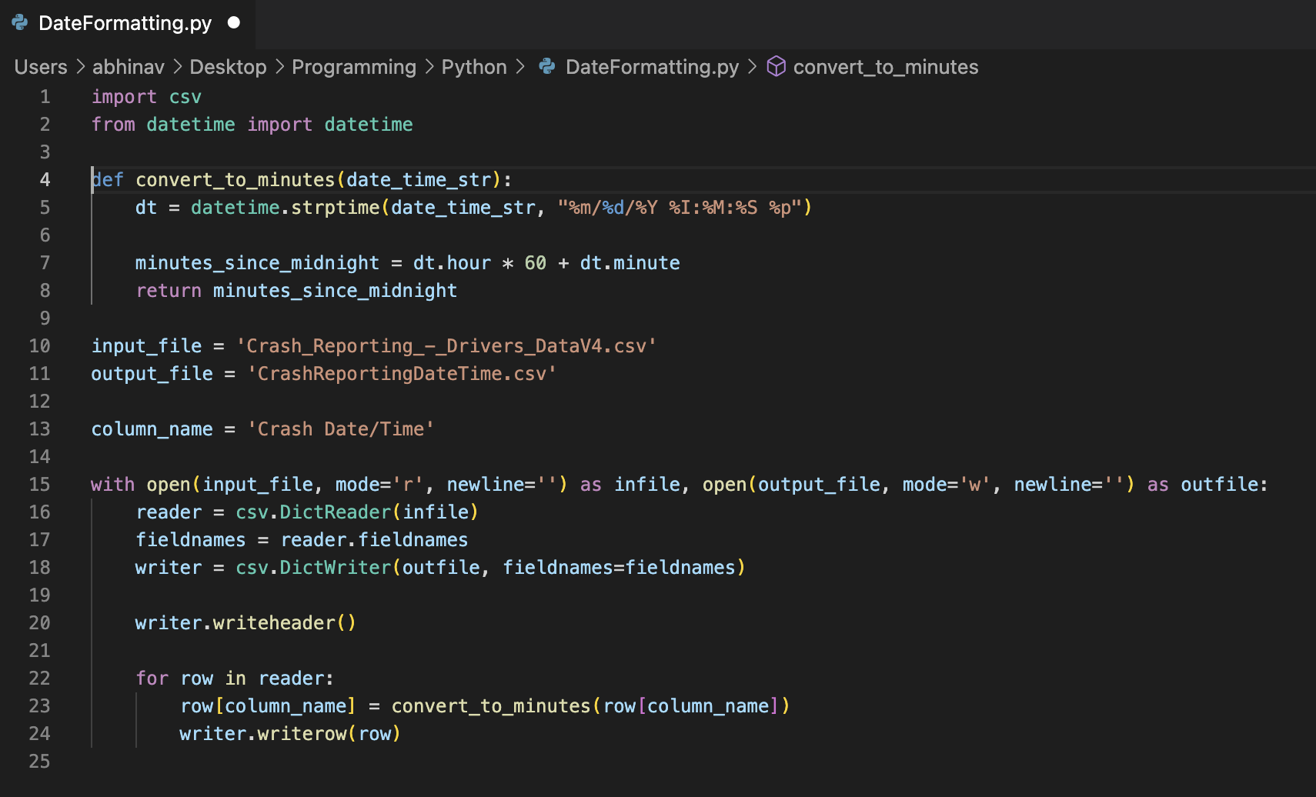

The code follows the only column with the date and time, and converts it to minutes.

For an example of how this transformed our data, consult the image.

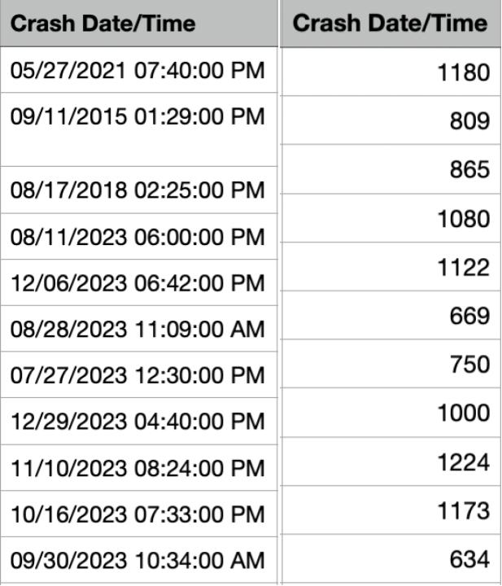

**Removing Immediately Useless Attributes**

The attributes that we concluded may be immediately removed from the dataset were ‘Report Number’ , ‘Local Case Number’, ‘Off Road Description’, ‘Municipality’, ‘Related Non-Motorist’, ‘Non-Motorist Substance Abuse’, ‘Person ID’, ‘Vehicle ID’, ‘Vehicle Model’, ‘Location’, ‘Circumstance’, and ‘Vehicle Make’. Several attributes such as report number, case number, person ID, and vehicle ID were removed due to being several long identifying strings that were randomly generated. By definition, they should not have any predictive value. The attribute ‘vehicle model’, proved to be too inconsistent when being inputted, and seemed to be beyond the help of any data smoothing. Location was redundant itself with the presence of the attributes ‘latitude’ and ‘longitude’. Then, ‘Off Road Description’, ‘municipality’, ‘related non-motorist’, and ‘non-motorist substance abuse’ were very sparsely populated, with under 10% of the instances containing values. ‘Circumstance’ conveyed redundant information already given by ‘Surface Condition’, and we decided to remove ‘Vehicle Make’ because of the inconsistency of the values: there were several, different misspellings of ‘Toyota,’ for example. Finally, ‘Road Name’ had over 1000 different qualitative values, which would have made our classification algorithms too slow. This leaves us with 24 attributes excluding the class label to aid us with our prediction model.

**Filling in missing values**

The attributes with missing values include Route Type (18141, 10% missing), Road Name (18708, 10% missing), Surface Condition (17155, 9% missing), Traffic Control (1120, 1% missing), Injury Severity (789, 0% missing), Driver Distracted By (862, 0% missing), Drivers License State (11432, 6% missing), Vehicle First Impact Location (156, 0% missing), Vehicle Body Type (2597, 1% missing), Vehicle Movement (927, 1% missing), Vehicle Going Dr (4744, 3% missing), and Parked Vehicle (1534, 1% missing).

These were all replaced using WEKA’s built in unsupervised ‘ReplaceMissingValues’. There were no instances in which the class label was not filled in, so this was a valid step to take.

**Discretize**

The main target of discretization was the ‘Crash Date/Time’. By converting it to minutes, we hoped that discretizing it would provide a good sense of ‘early morning’, ‘midday’, ‘evening’ and ‘night’. Some numerical attributes, like "Latitude," were also binned. The discretization method varied, with some attributes using equal width and others using equal depth, depending on factors such as the presence of outliers and data distribution. This way, we were able to use classification algorithms even with initially continuous data.

**Train Test Split**

We did a stratified random train/test split with the use of Weka’s “stratifiedRemoveFolds”, yielding an 80-20 split stratified with respect to the class label “At Fault”. The resulting train and test splits had the same percentage of each class (to the nearest whole instance).

**Attribute Selection**

As stated previously, we had 25 attributes to work with to aid our prediction of ‘Driver At Fault.’ To narrow down the most useful attributes, we created five different datasets based on several different attribute selection algorithms and reasoning.

**Correlation Based Feature Selection**

Using the CorrelationAttributeEval attribute selection algorithm and the Ranker search method, we obtained the following analysis.

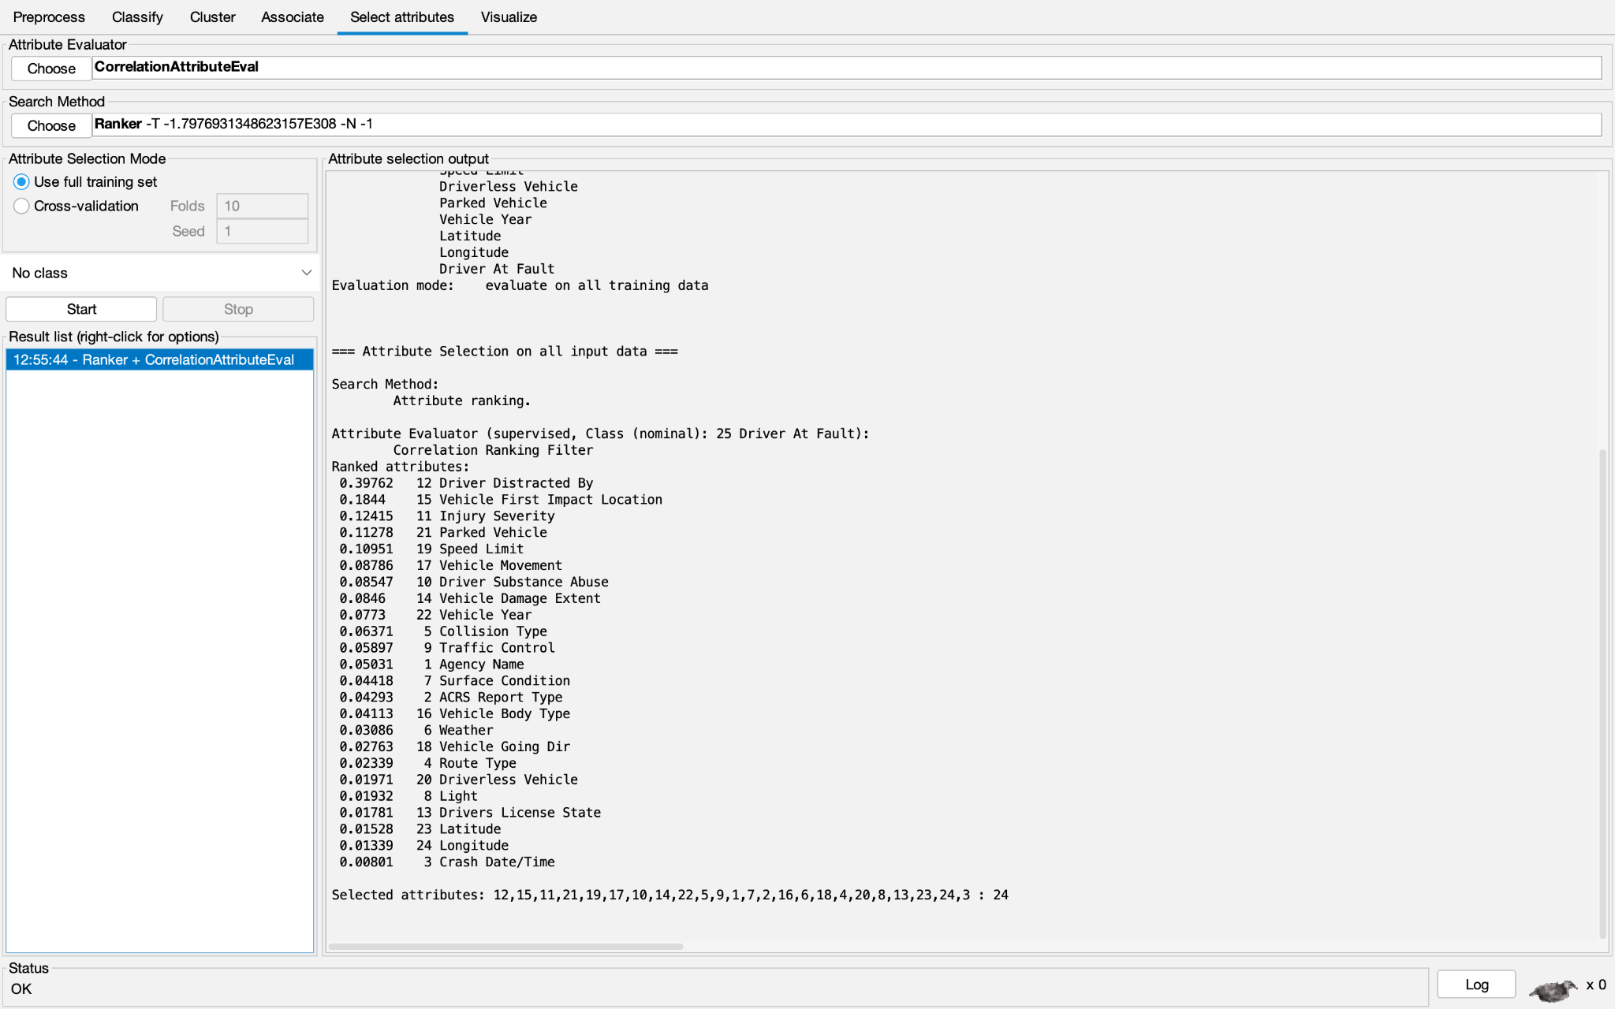

When selecting our attributes, we set a cutoff of 0.075. Thus, the following attributes were selected to be included based on this algorithm: ‘Driver Distracted By’, ‘Vehicle First Impact Location’, ‘Injury Severity’, ‘Parked Vehicle’, ‘Speed Limit’, ‘Vehicle Movement’, ‘Driver Substance Abuse’, ‘Vehicle Damage Extent’, and ‘Vehicle Year’.

**Info Gain Based Attribute Selection**

Our second dataset was created using the InfoGainAttributeEval algorithm provided by WEKA, which also uses the Ranker search method.

The results are shown below.

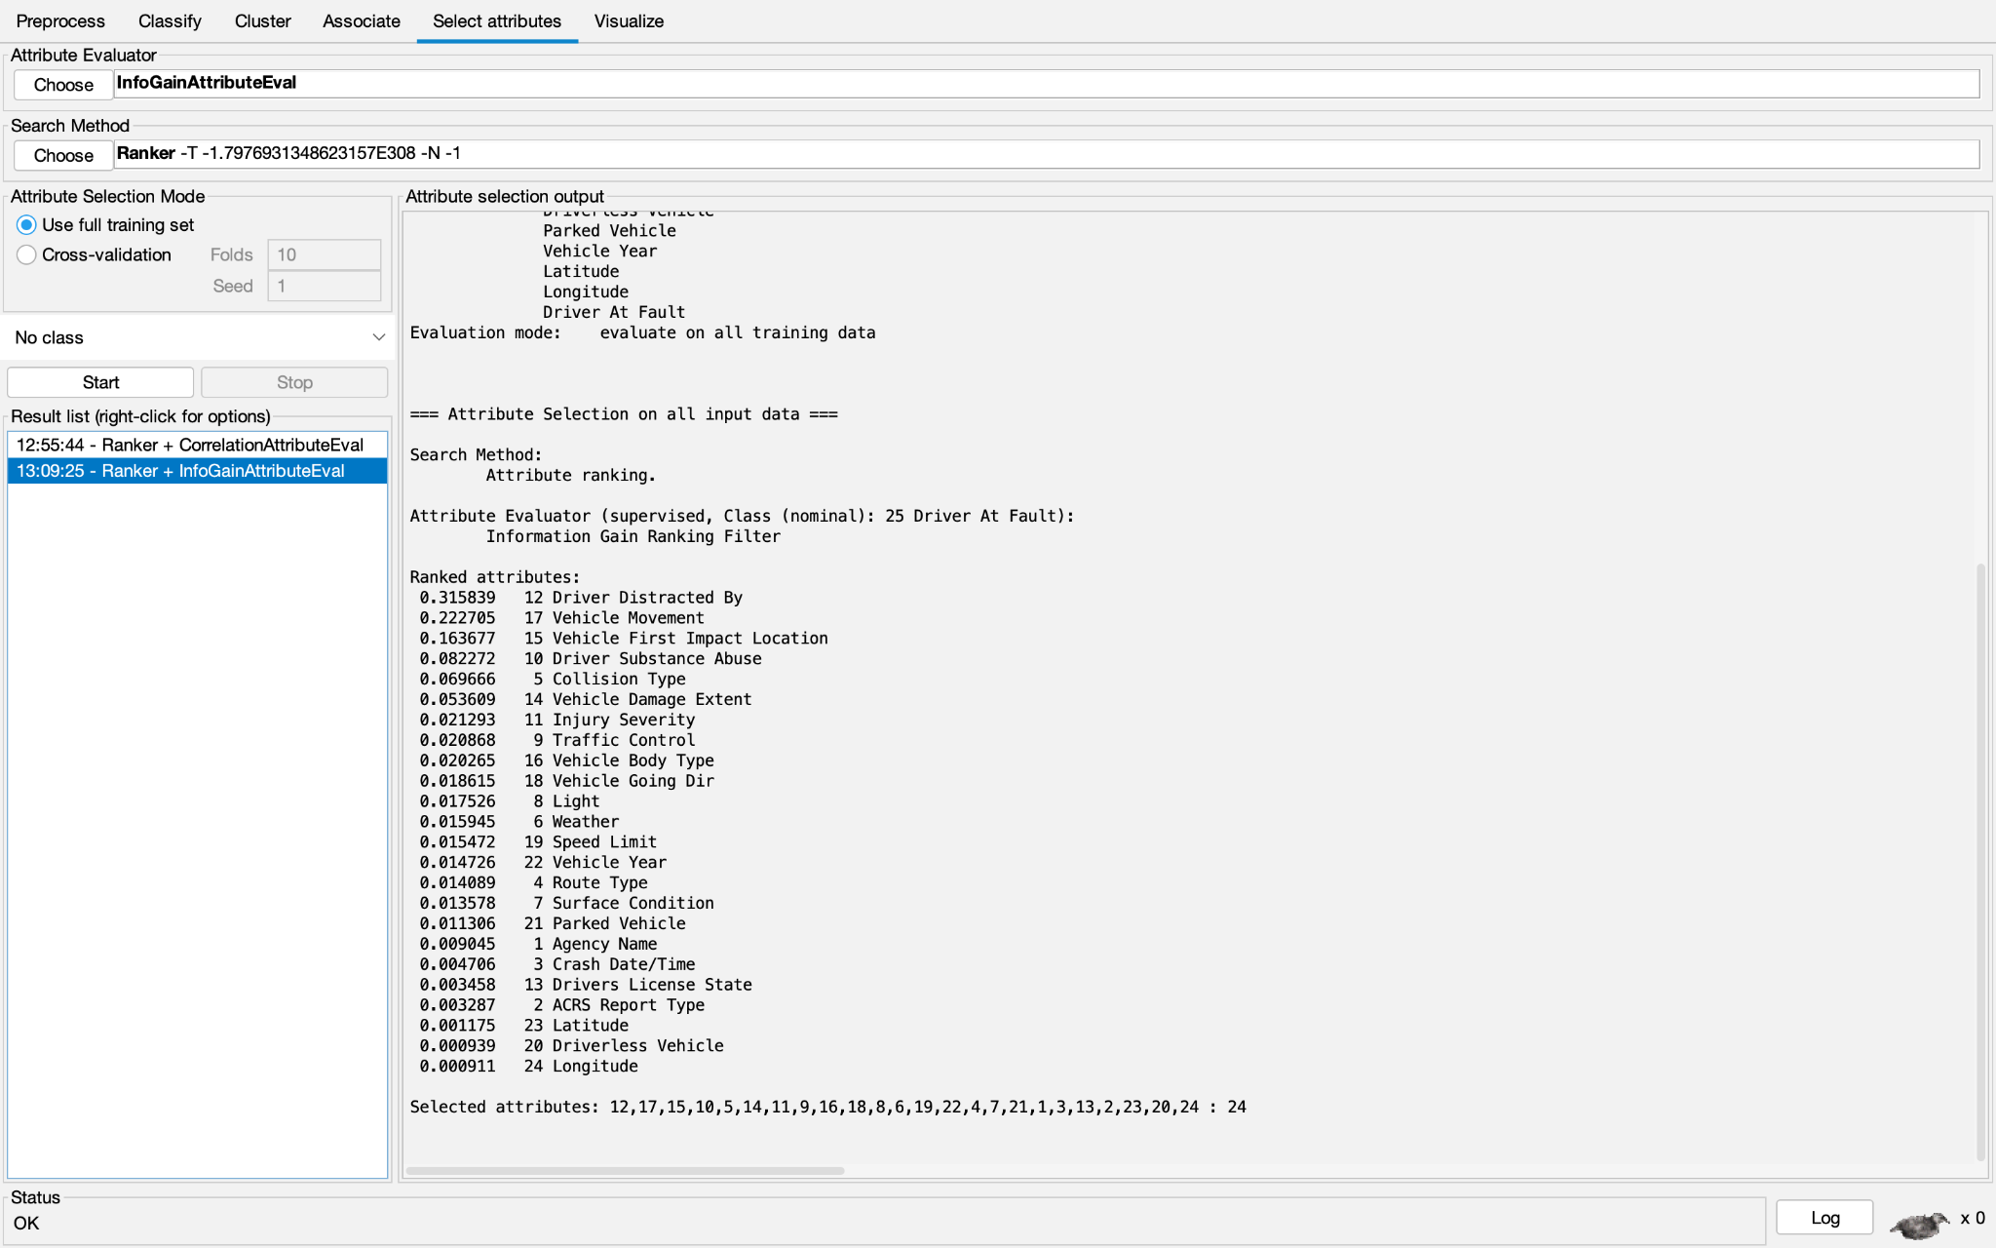

We chose a cutoff of 0.02. As such, we kept the attributes ‘Driver Distracted By’, ‘Vehicle Movement’, ‘Vehicle First Impact Location’, ‘Driver Substance Abuse’, ‘Collision Type’, ‘Vehicle Damage Extent’, ‘Injury Severity’, ‘Traffic Control’, and ‘Vehicle Body Type’.

**One Attribute Based Selection**

This dataset was created using the OneRAttributeEval attribute evaluator, which uses the Ranker search method. The following results were obtained.

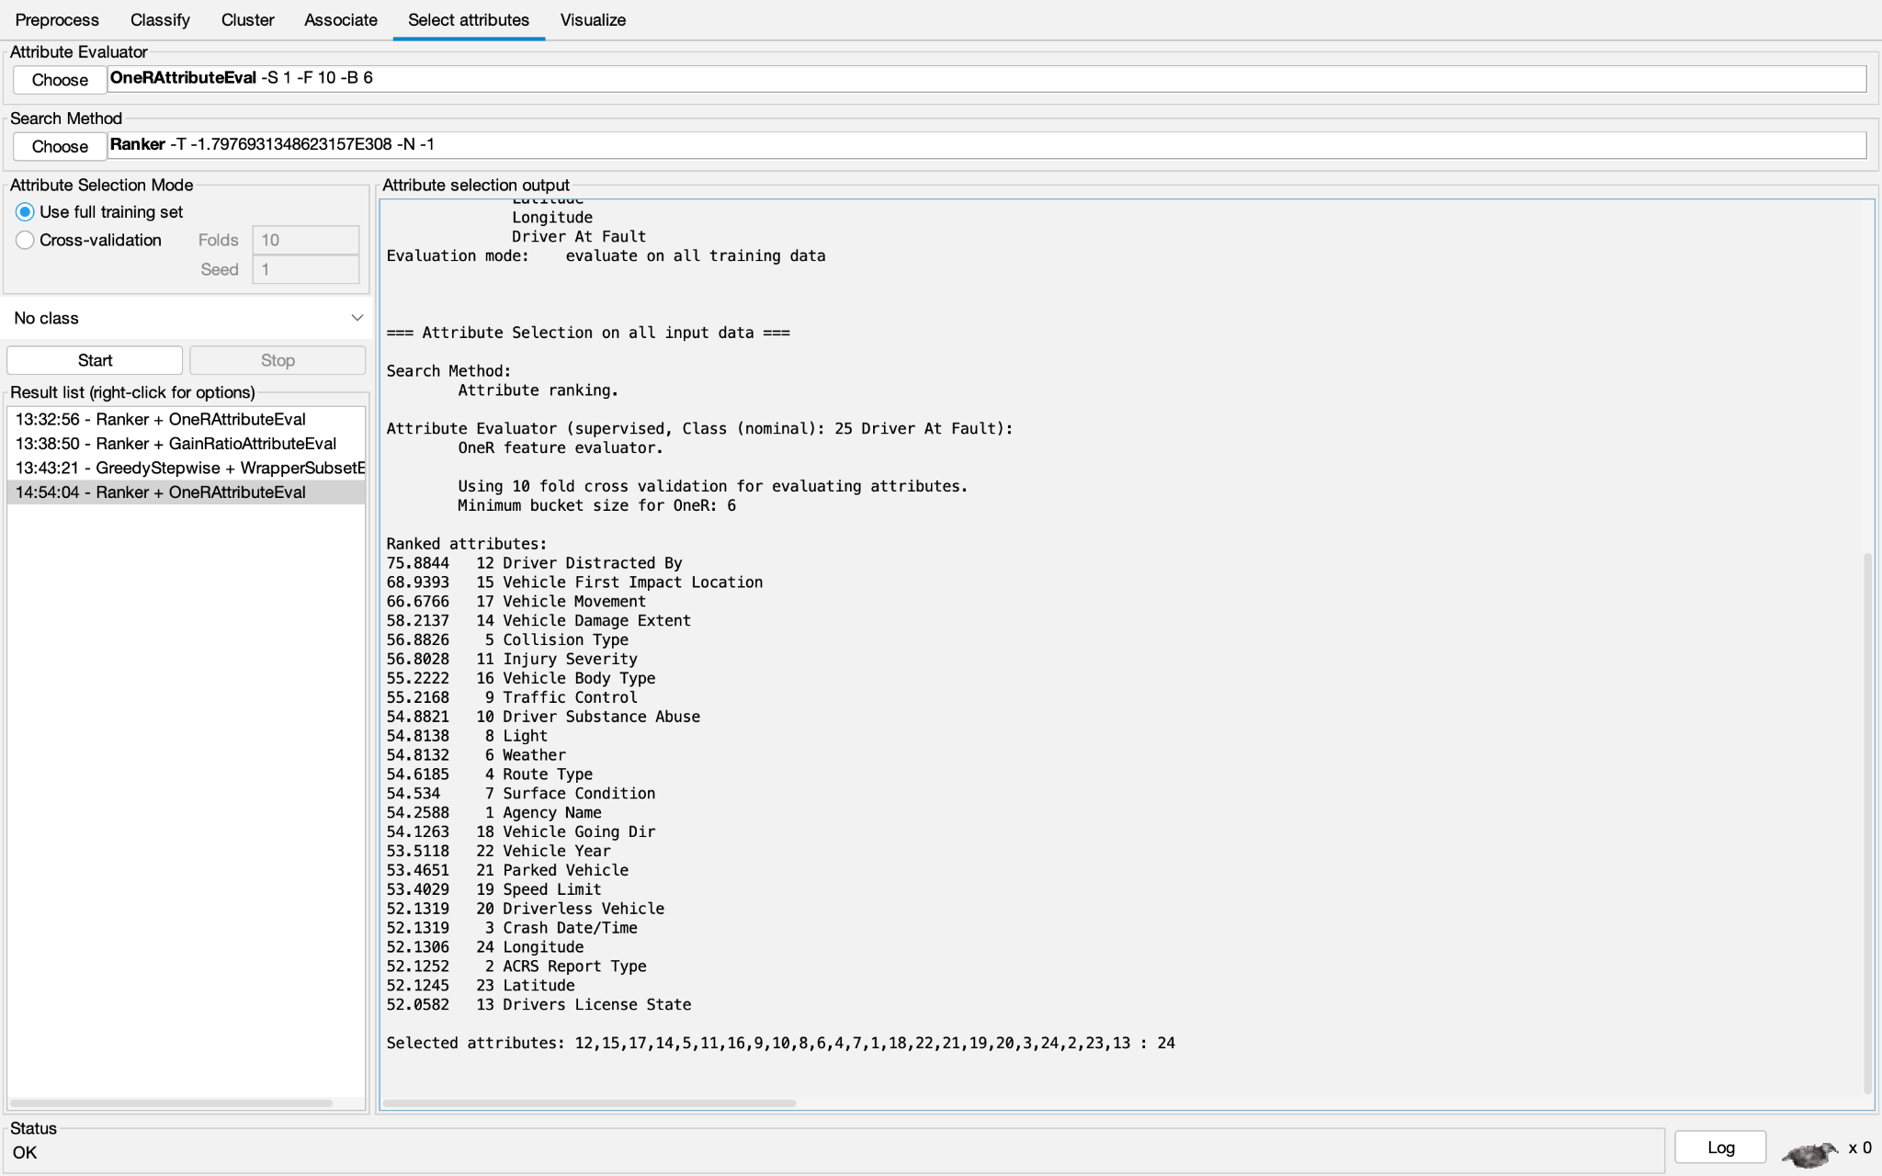

Based on the cutoff value of 54.5, the attributes we chose to keep were: ‘Driver Distracted By’, ‘Vehicle First Impact Location’, ‘Vehicle Movement’, ‘Vehicle Damage Extent’, ‘Collision Type’, ‘Injury Severity’, ‘Vehicle Body Type’, ‘Traffic Control’, ‘Driver Substance Abuse’, ‘Light’, ‘Weather’, ‘Route Type’, and ‘Surface Condition’.

**Gain Ratio Evaluation**

This dataset was created using the GainRatioAttributeEval, which uses the Ranker search method. The results are shown below.

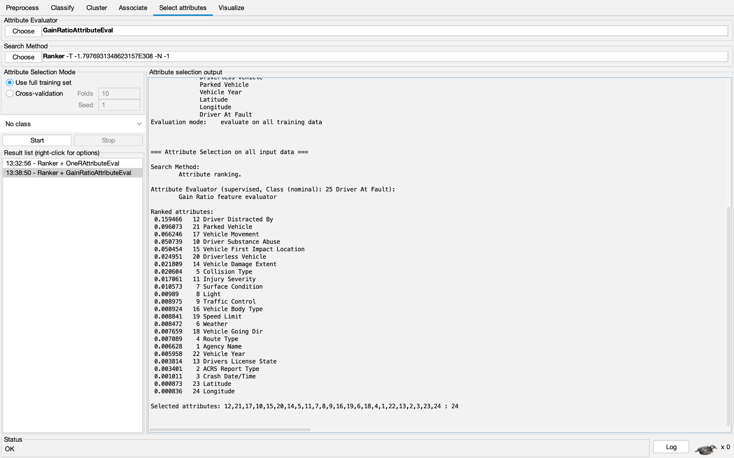

After setting a cutoff of 0.01, we decided to keep the following attributes: ‘Driver Distracted By’, ‘Parked Vehicle’, ‘Vehicle Movement’, ‘Driver Substance Abuse’, ‘Vehicle First Impact Location’, ‘Driverless Vehicle’, ‘Vehicle Damage Extent’, ‘Collision Type’, ‘Injury Severity’, and ‘Surface Condition’.

**Self Selected Attributes**

For the self-selected attributes, we chose to include any attribute that was suggested to be kept by *any* one of the attribute selection algorithms above. In other words, the only attributes removed were the ones that were considered ‘useless’ by every single attribute selection algorithm.

**Performance Analysis of Models**

The models we used were:

* J48
* Naive Bayes: This model forms probabilistic predictions based on the training set using Bayes’ theorem and the naive assumption that attributes are independent from one another. The following formulas are used:

$P(C_{i}|X)=\frac{P(X|C_{i}) P(C_{i})}{P(X)}$*when $P(X|C_{i})=\prod_{k=1}^{n}{}P(x_{k}|C_{i})$ where $X=(x_{1}, x_{2},..., x_{n})$ is the instance. The prediction is the class ${(C}_{i})$ with the highest $P(C_{i}|X)$ value.*

* 1R: Level 1 decision tree. It forms a rule set with the following pseudocode:

*For each attribute*

*For each value of the attribute*

*count frequency of each class*

*find the most frequent class*

*make rule: assign that class to this attribute-value*

*Compute the error rate of the rules (of this attribute)*

*Choose the rules with the smallest error rate*

* Random Tree

**Results**

Naive Bayes: CorrelationAttributeEval

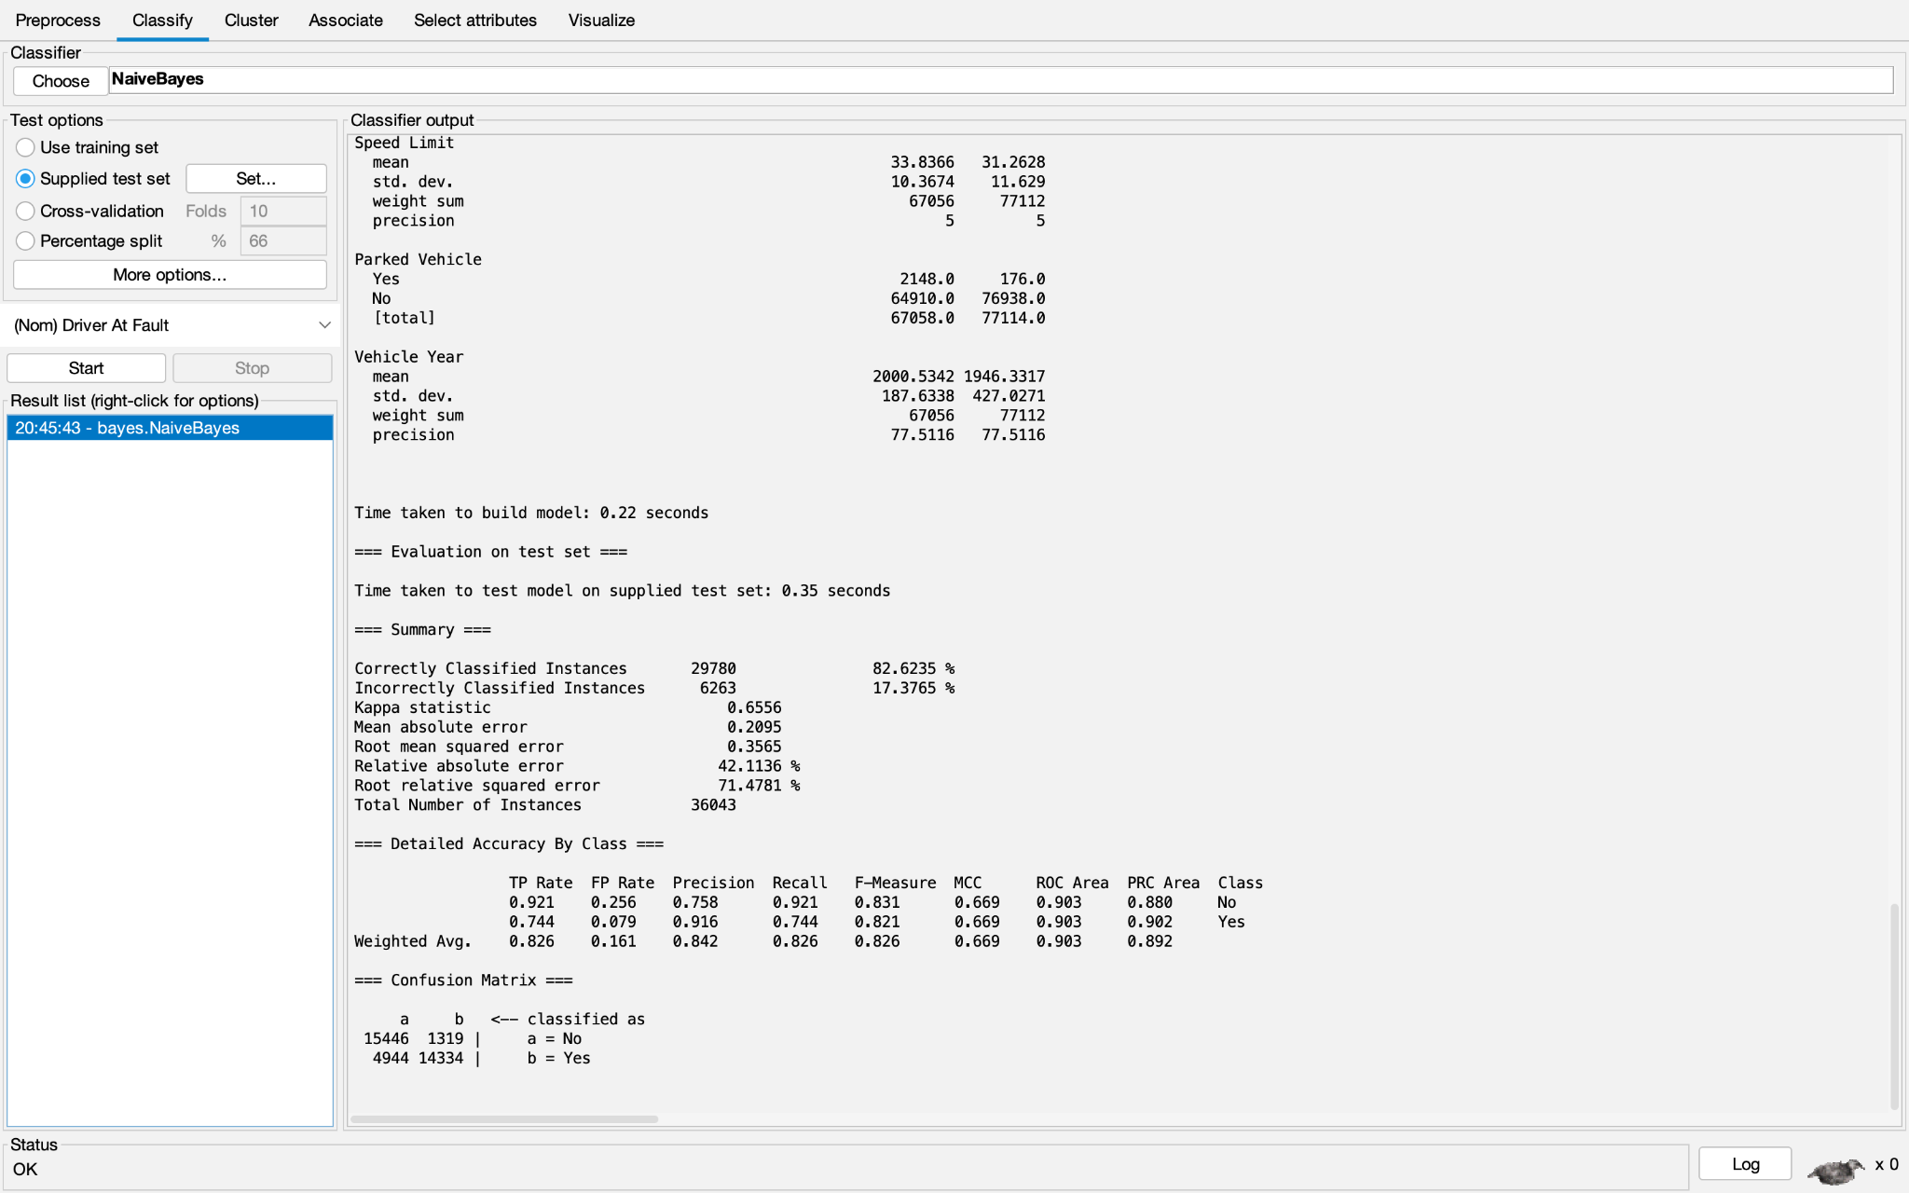

J48: CorrelationAttributeEval

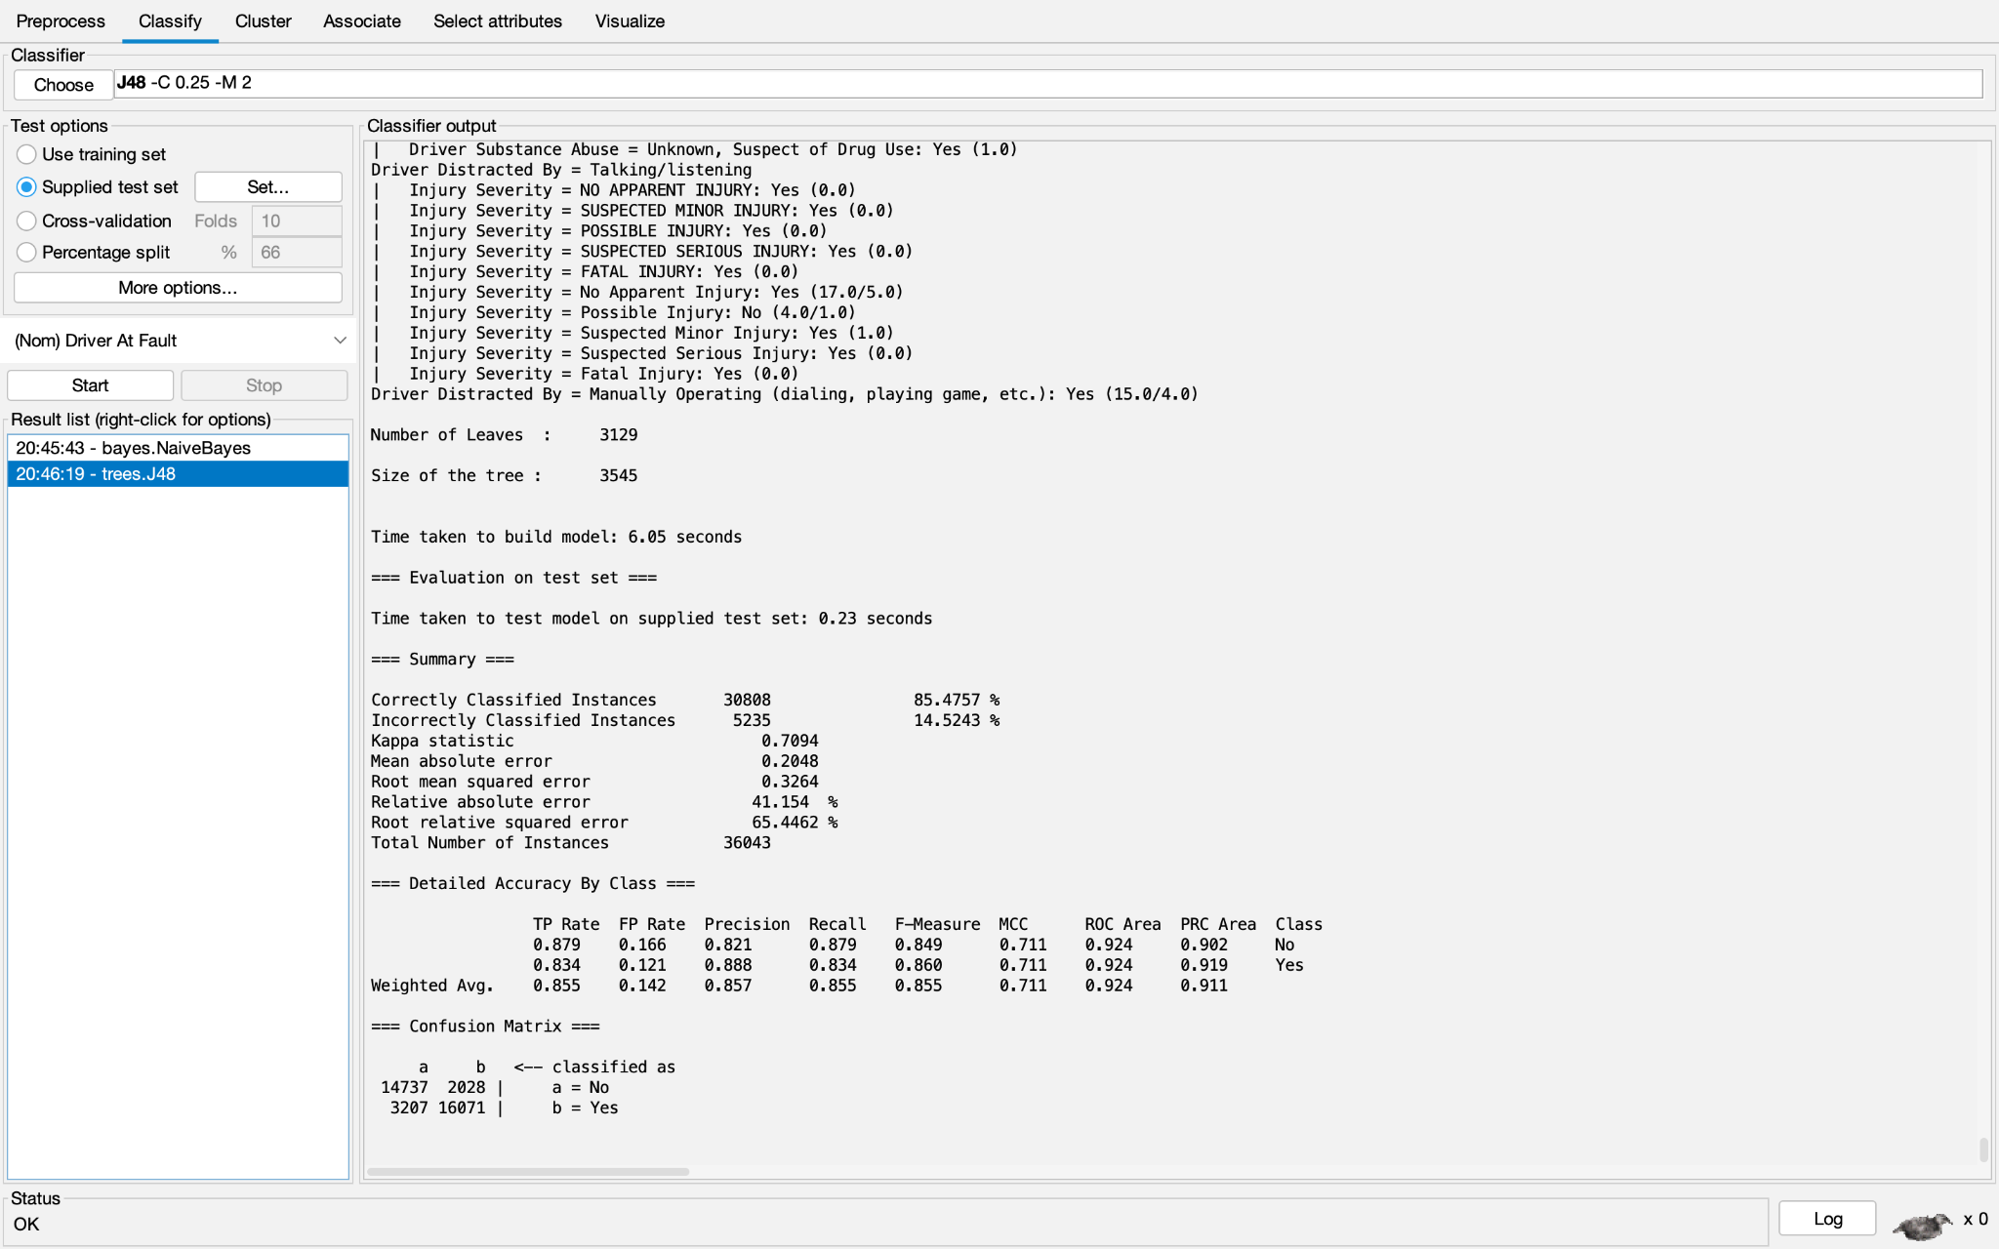

OneR: CorrelationAttributeEval

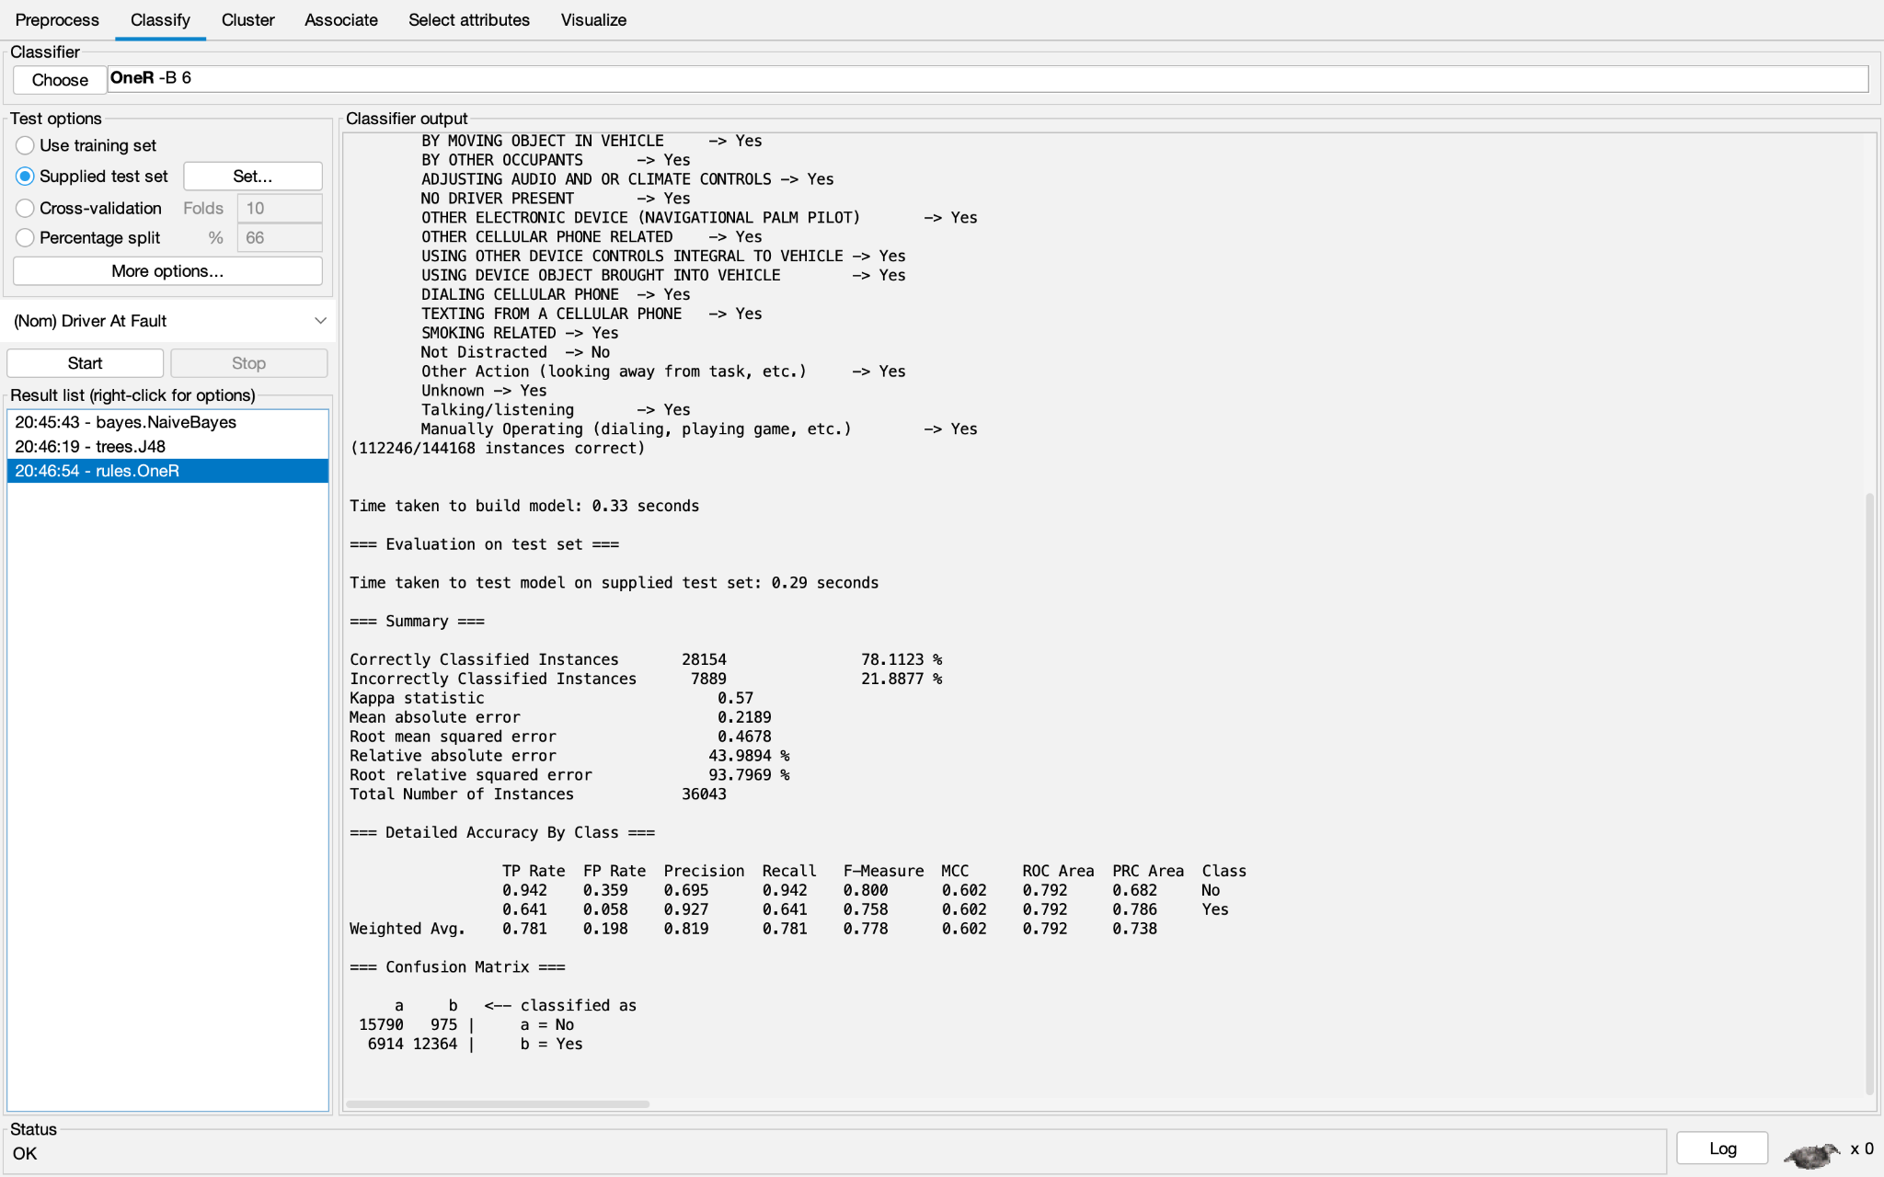

Random Tree: CorrelationAttributeEval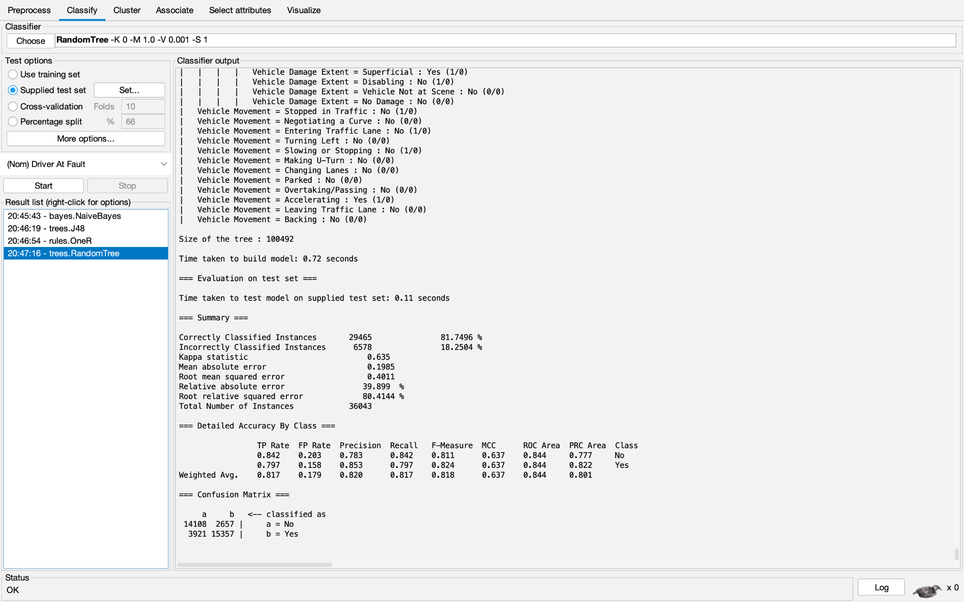

Naive Bayes: GainRatioEval

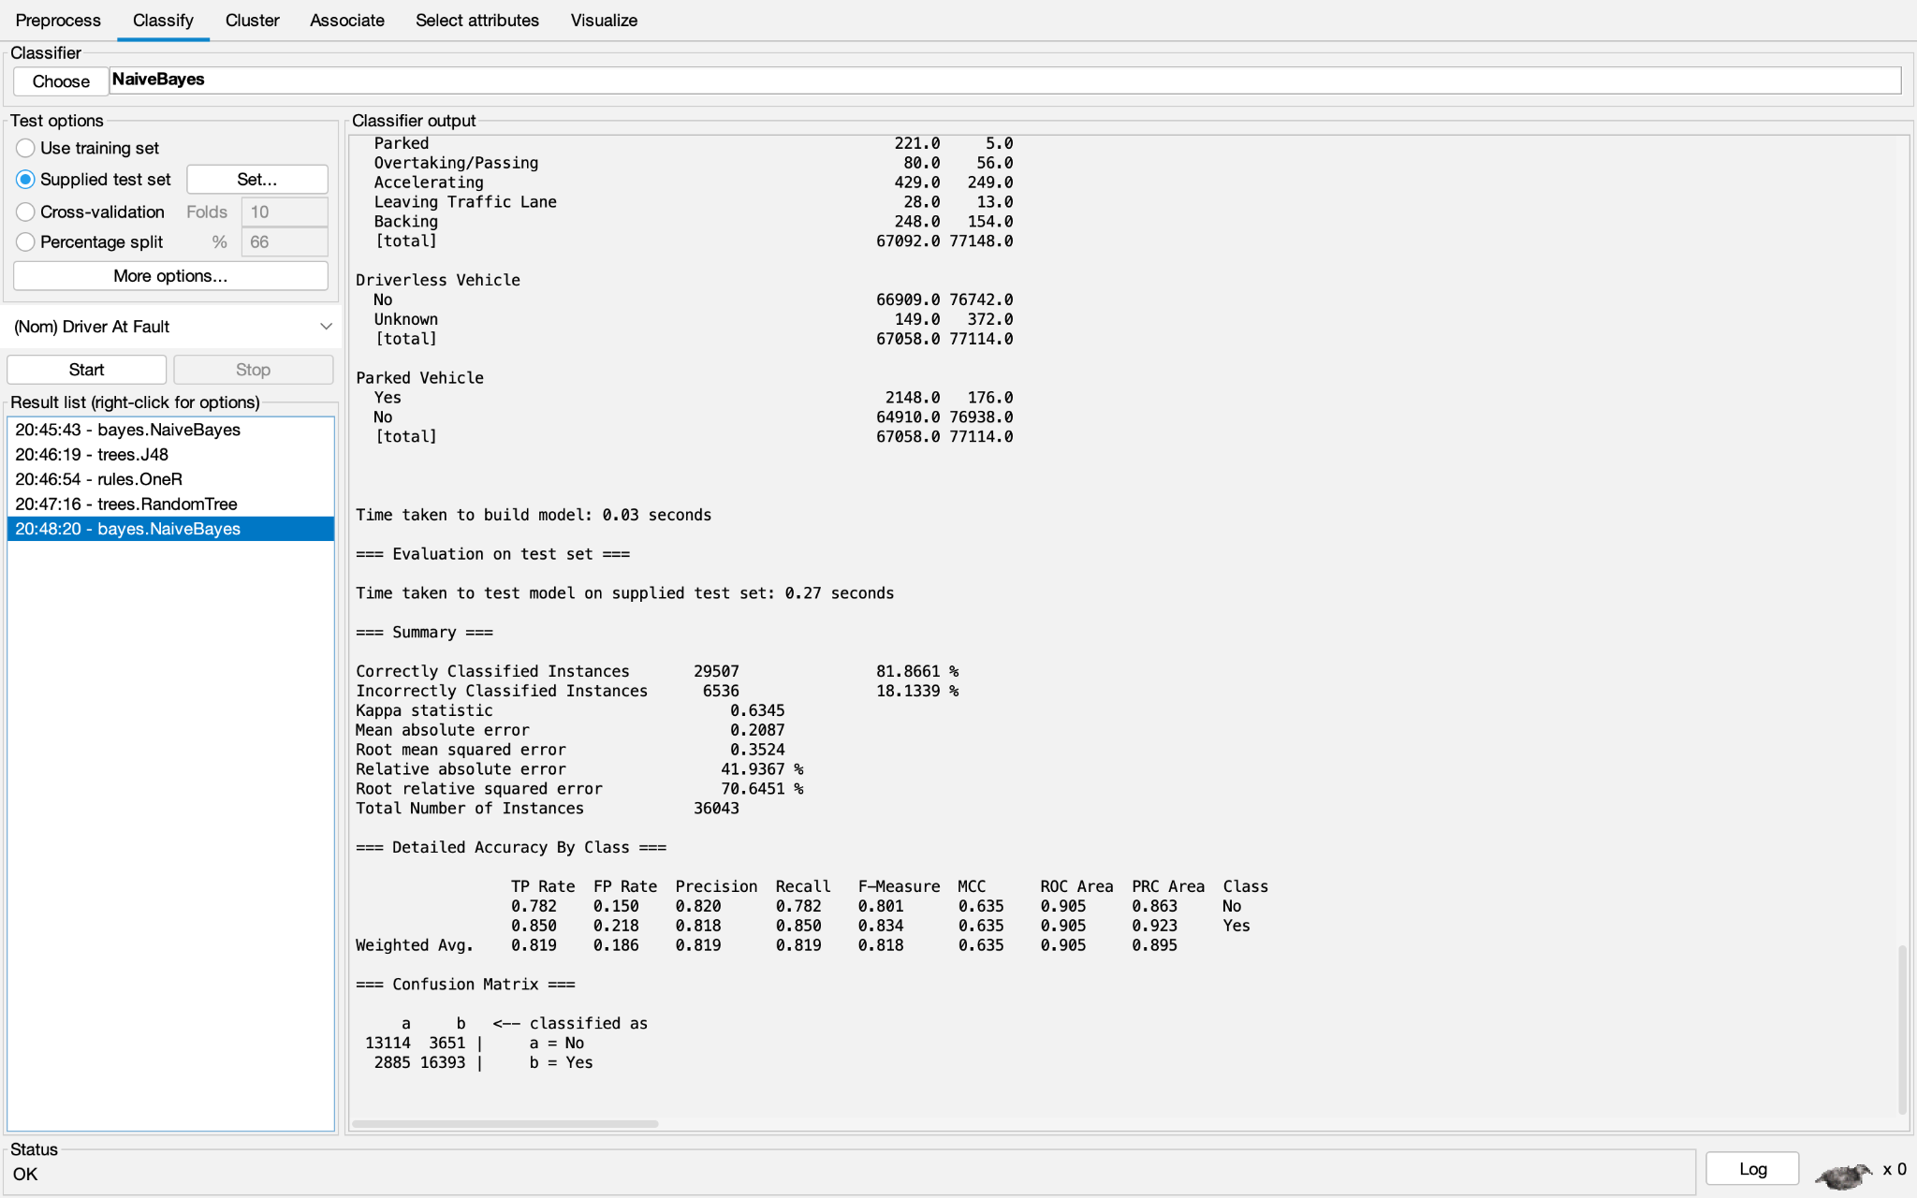

J48: GainRatioEval

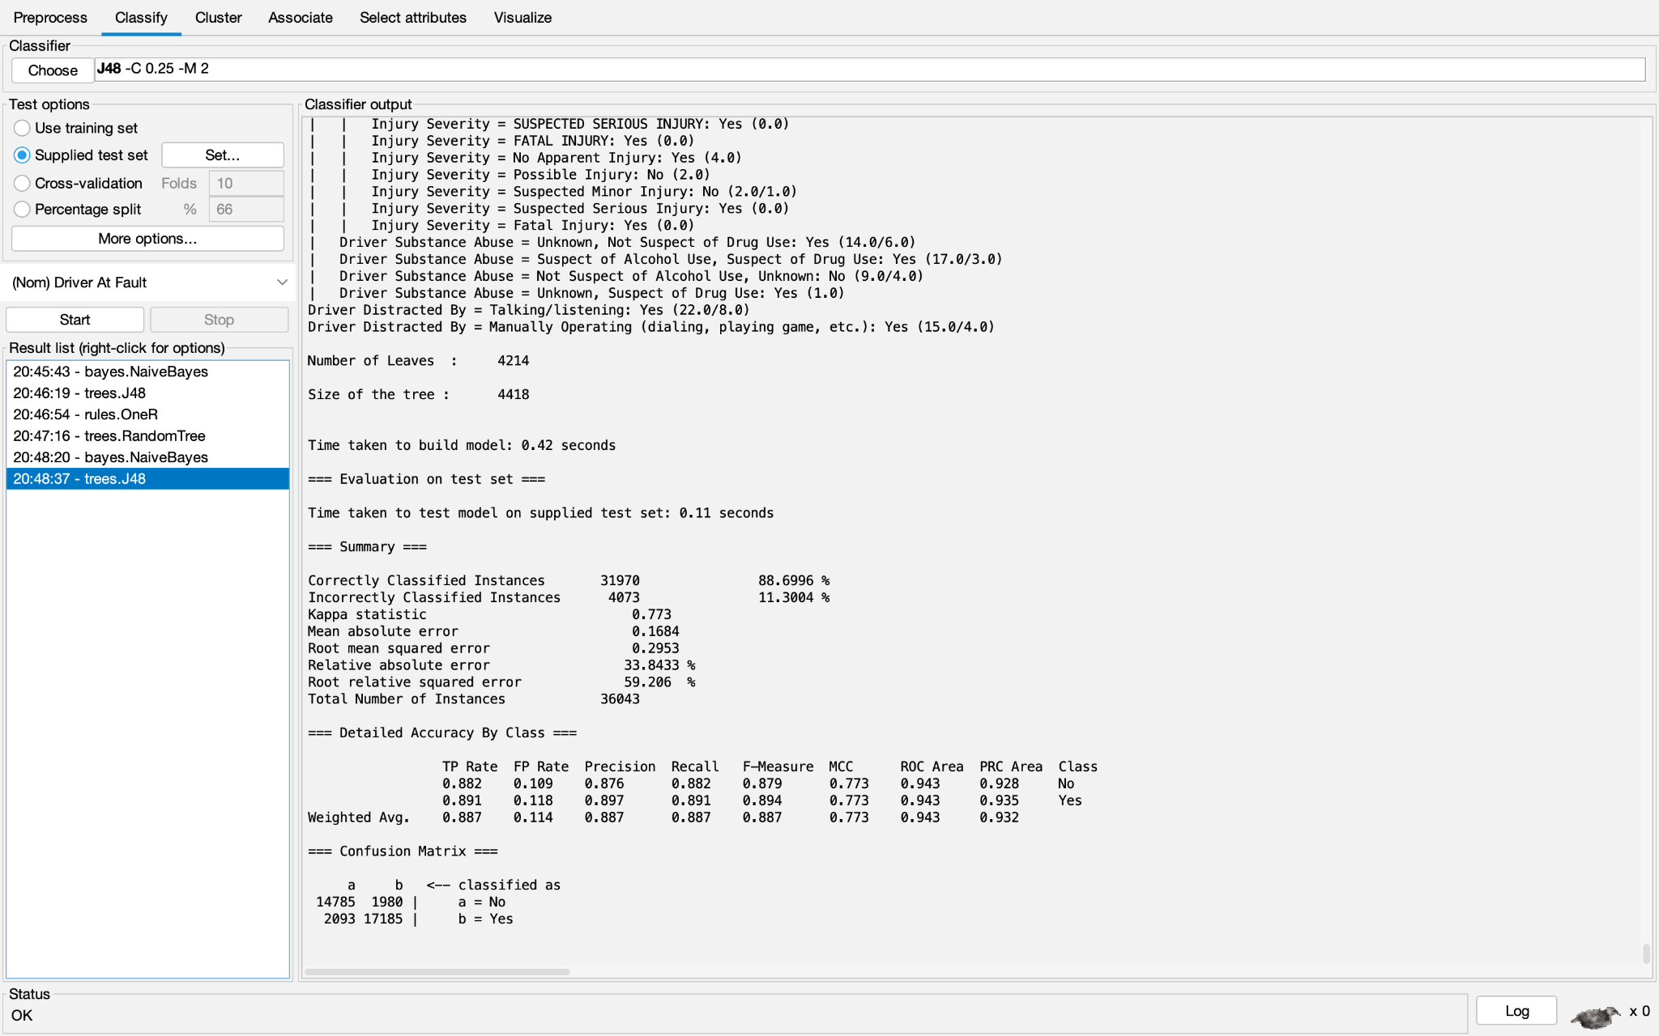

OneR: GainRatioEval

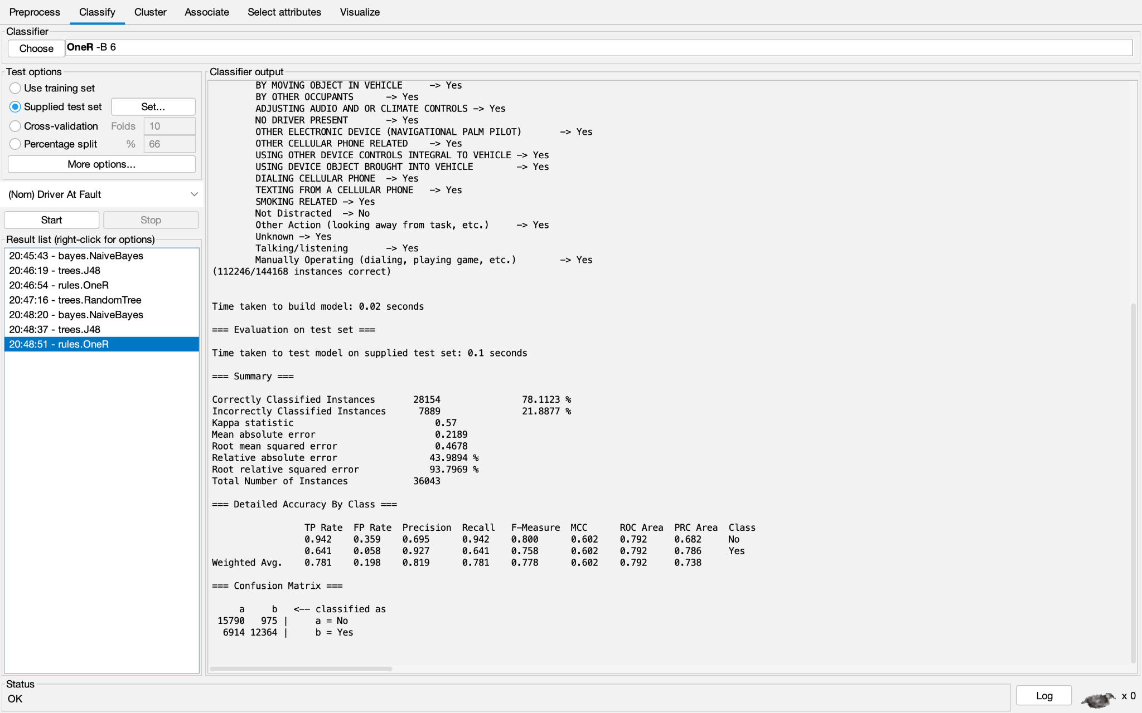

Random Tree: GainRatioEval

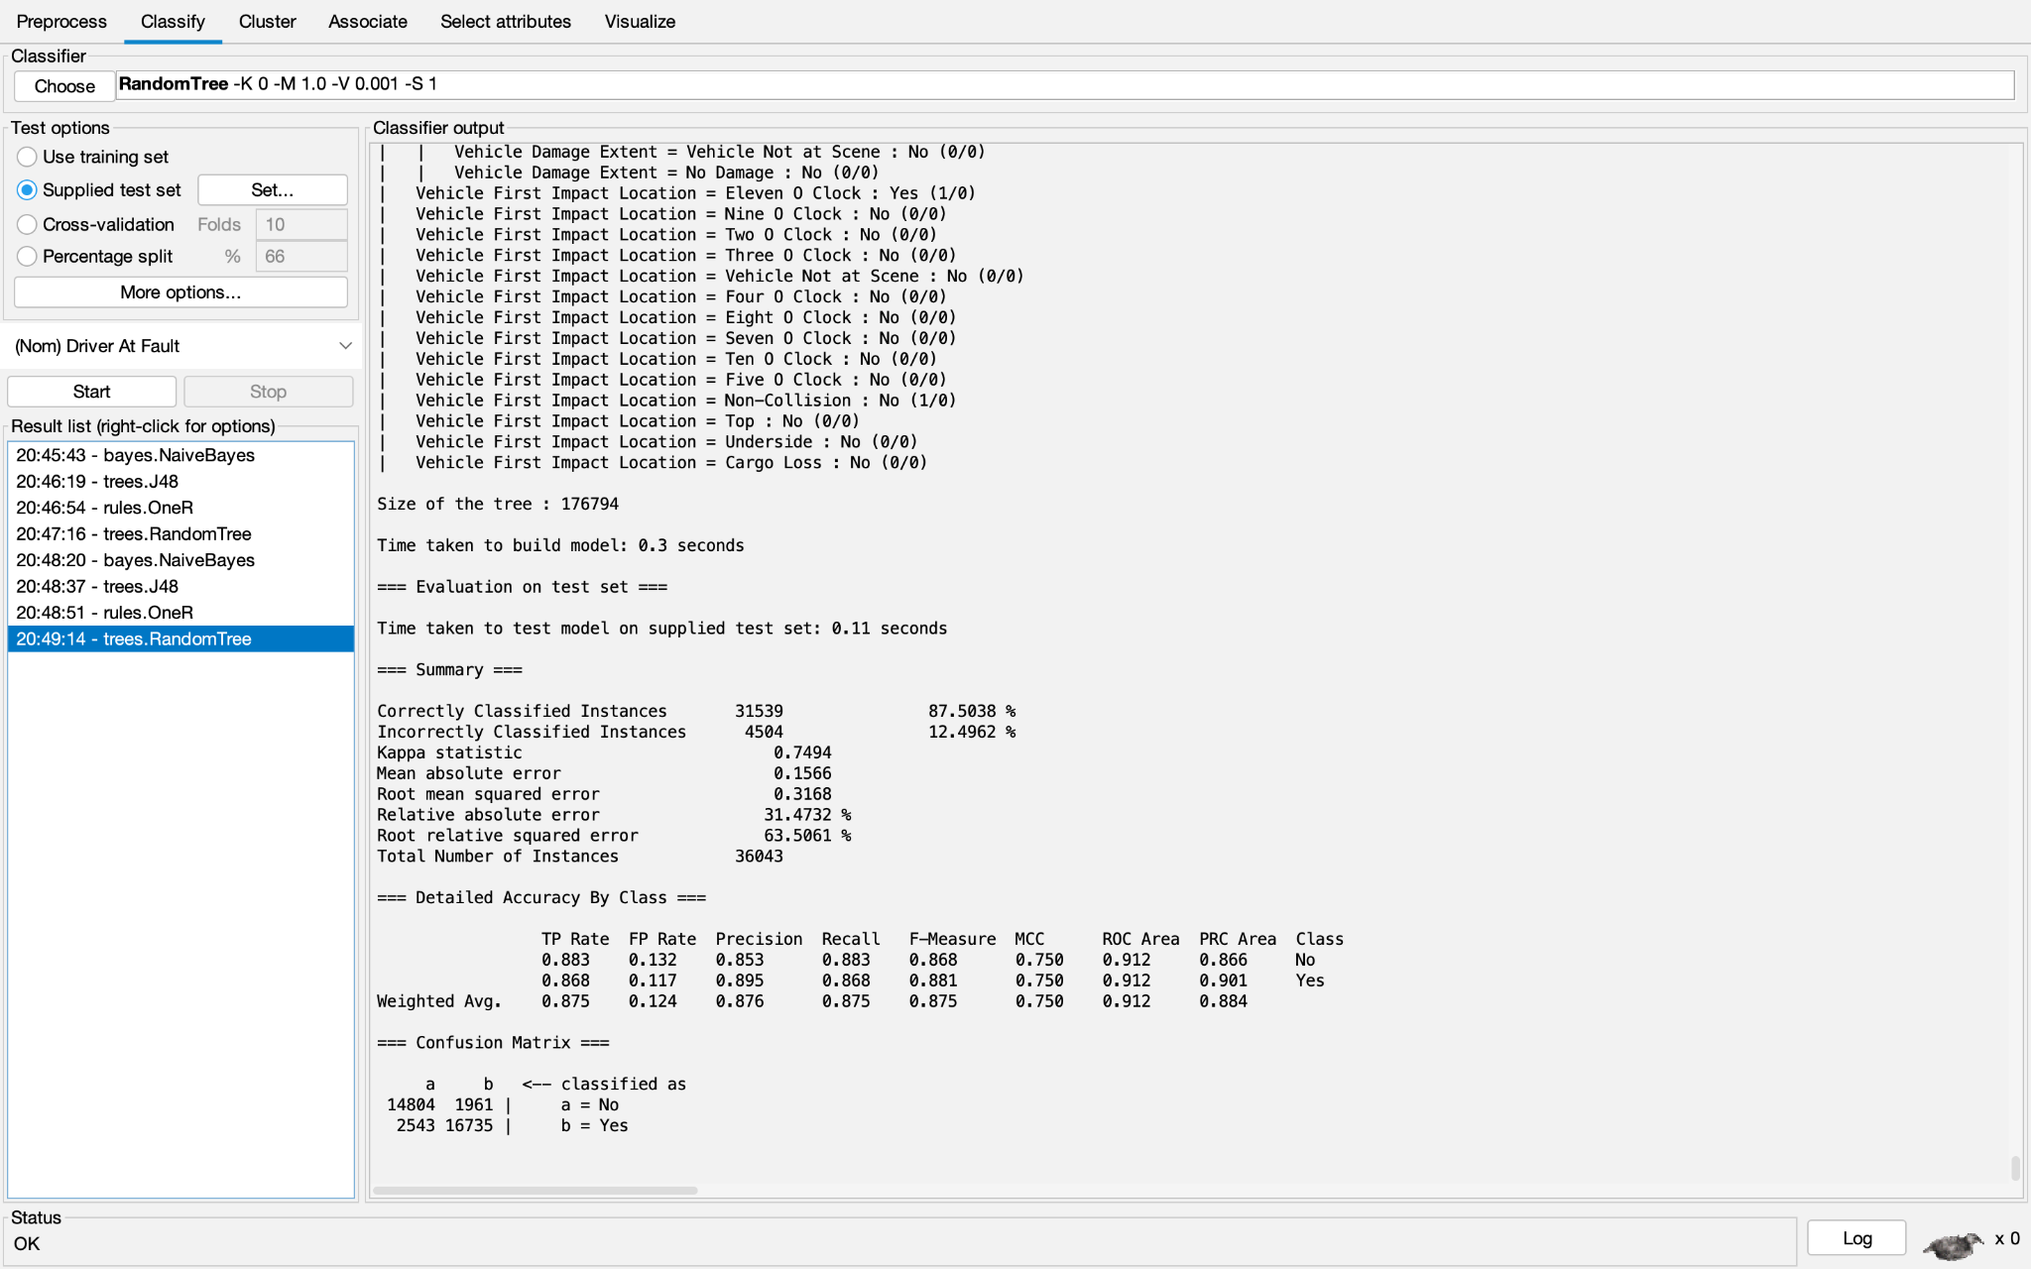

Naive Bayes: InfoGainEval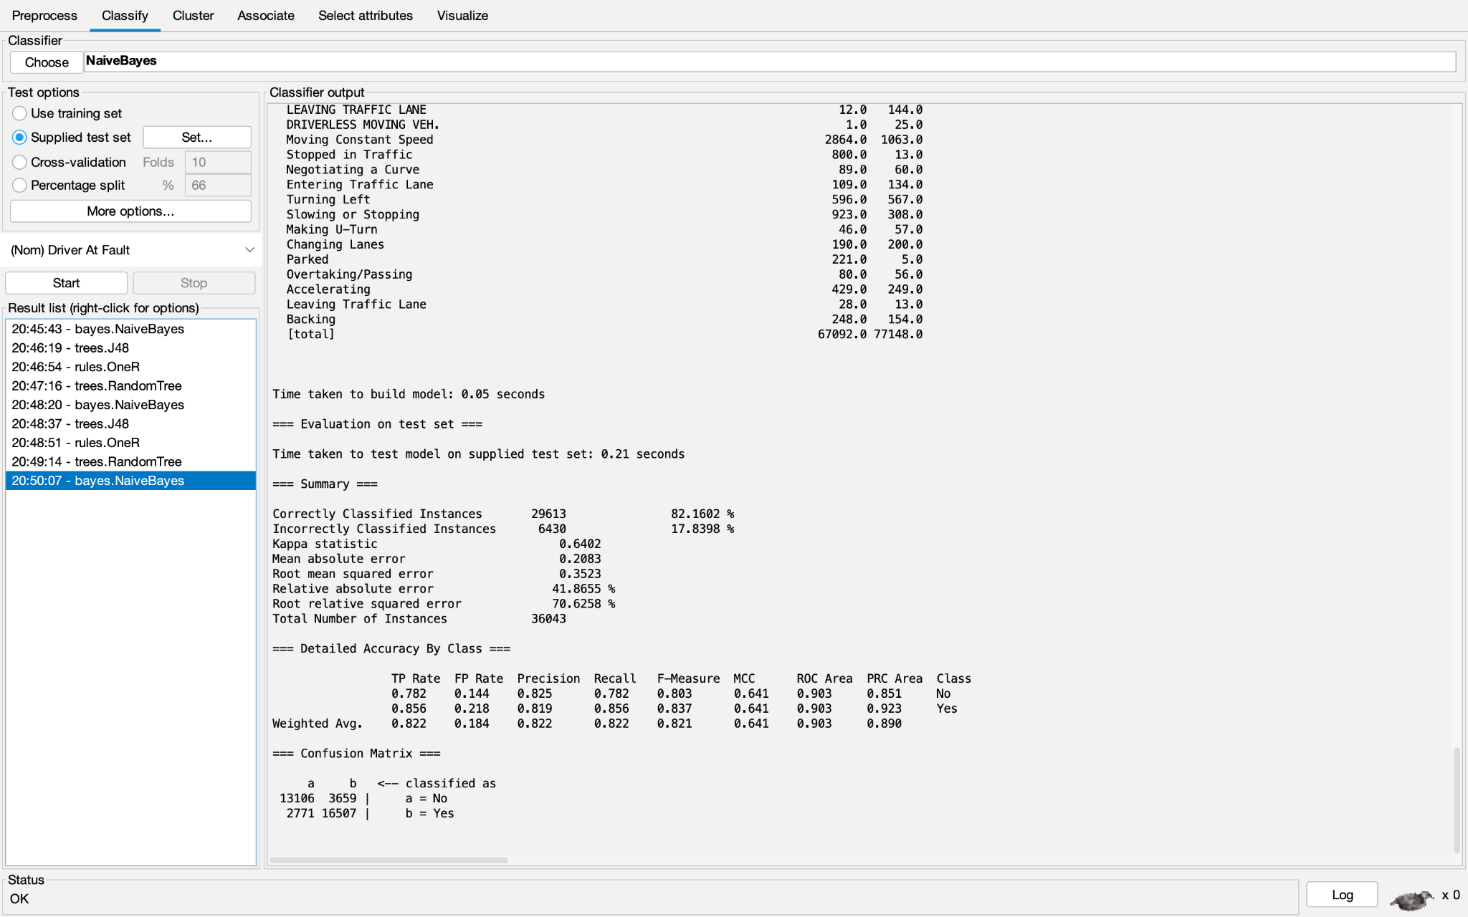

J48: InfoGainEval

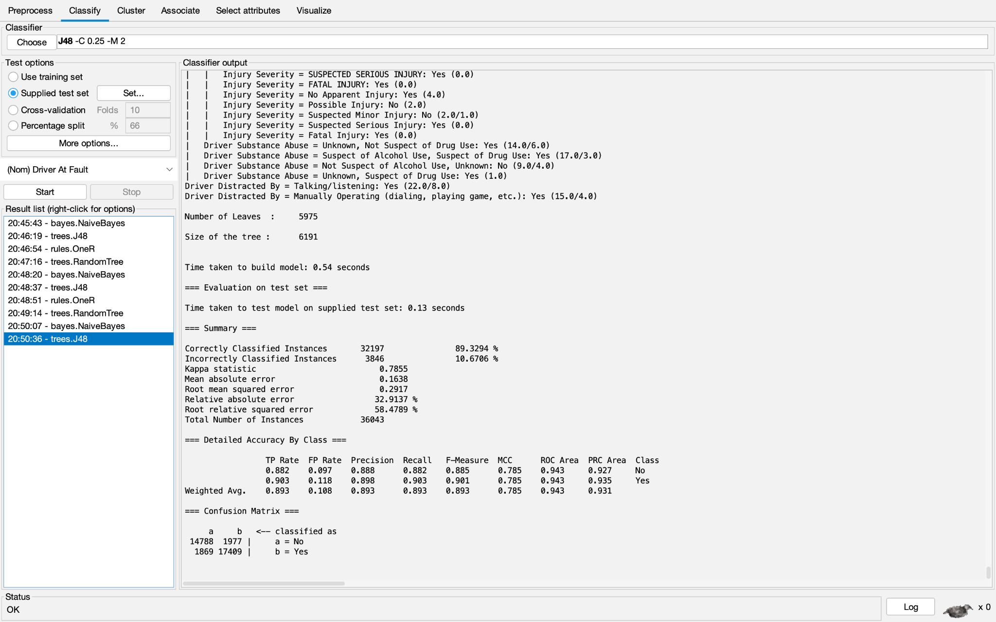

OneR: InfoGainEval

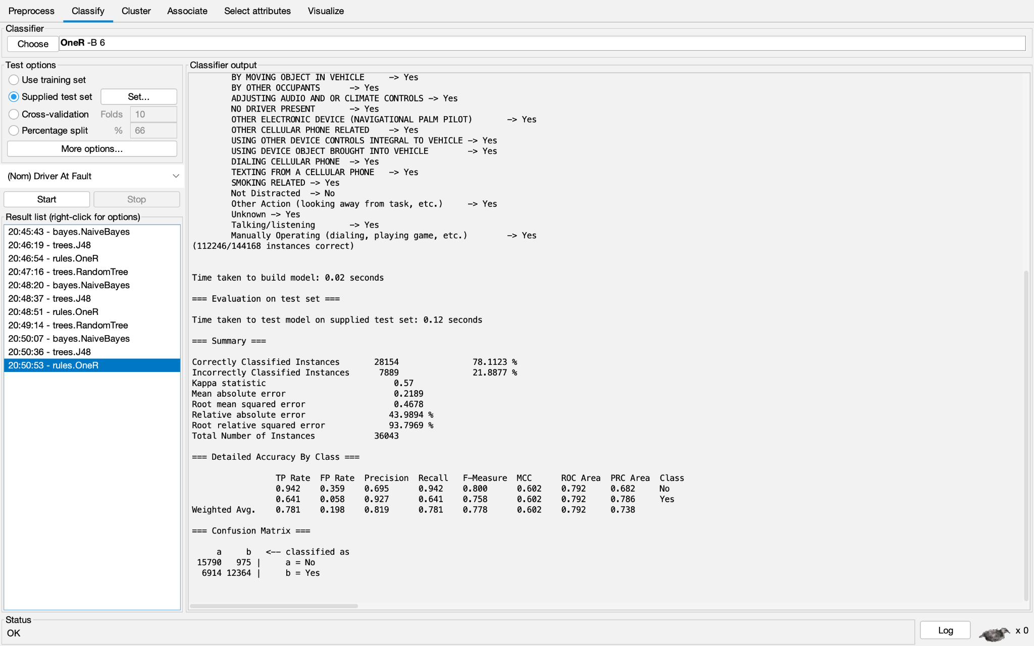

Random Tree: InfoGainEval

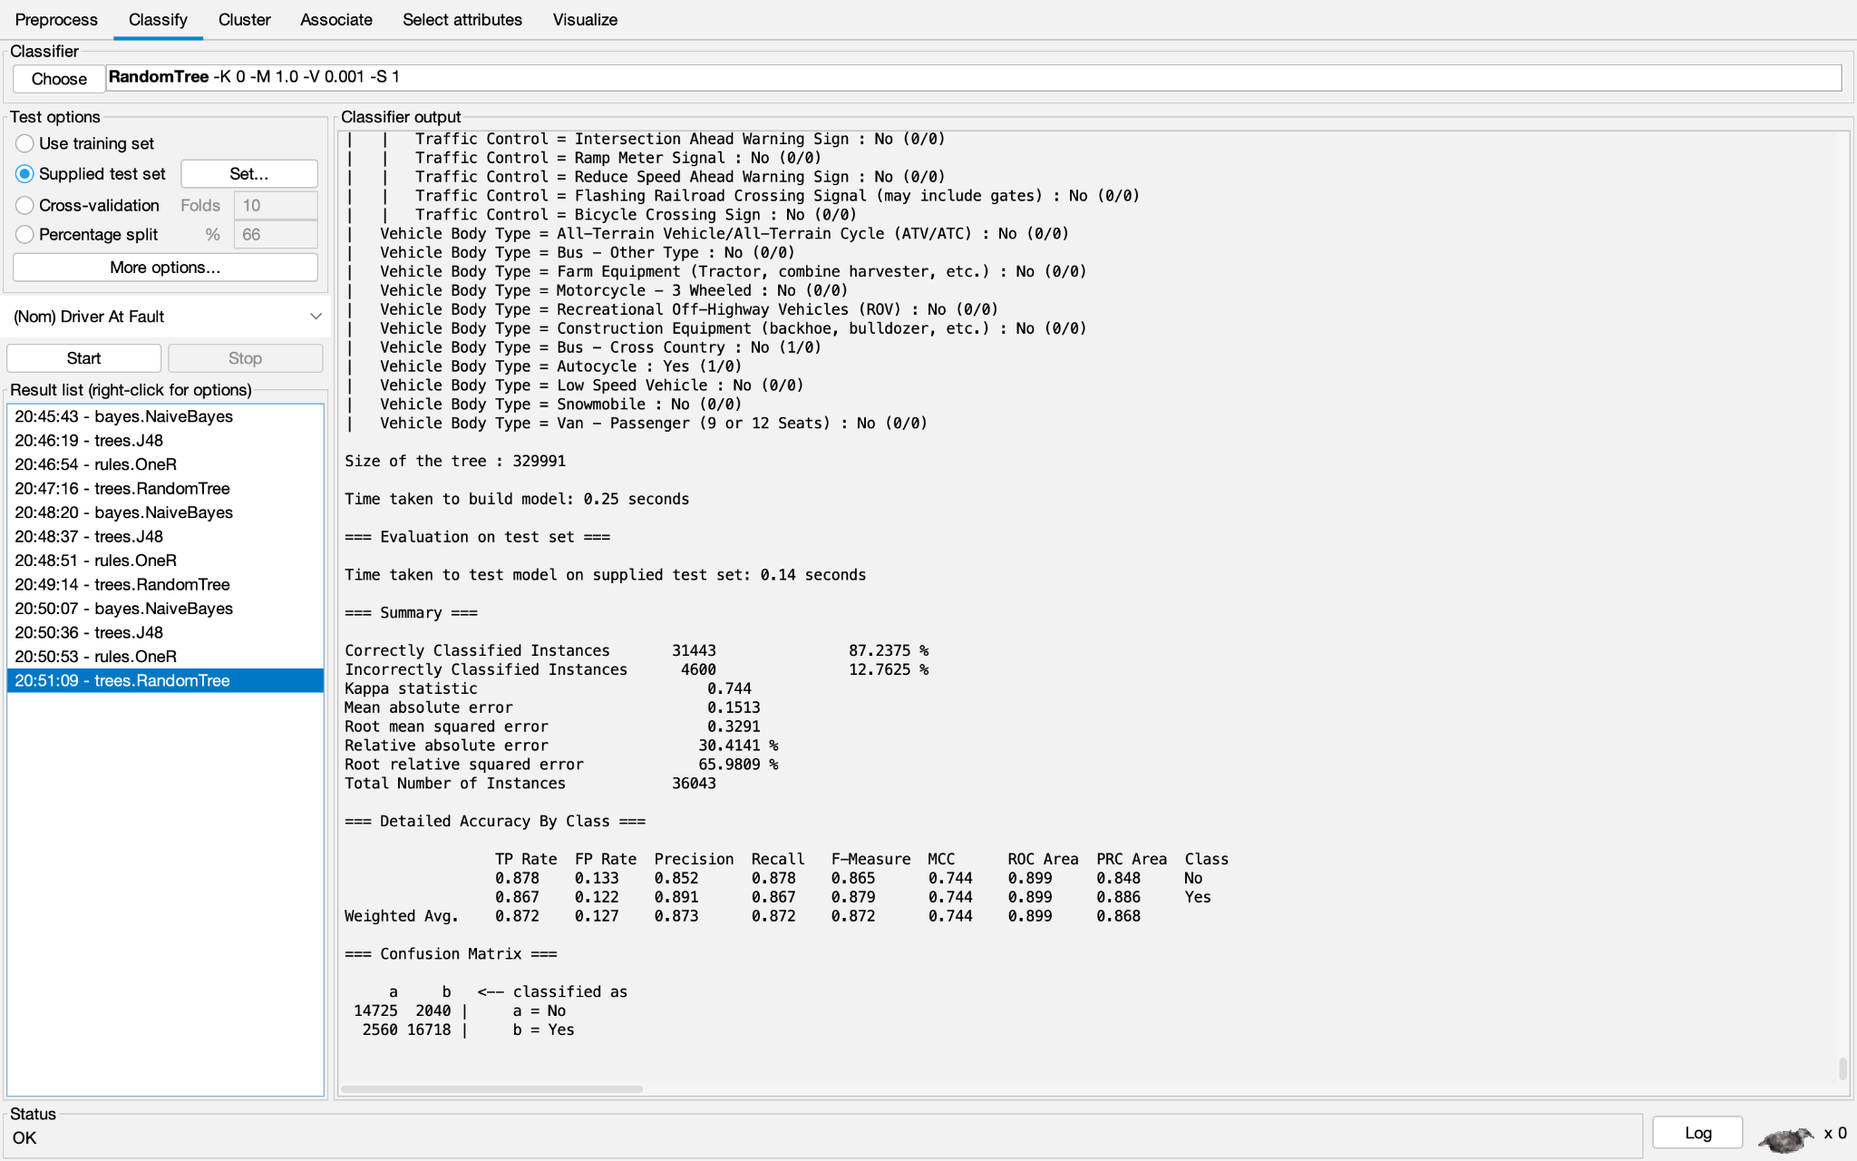

Naive Bayes: OneREval

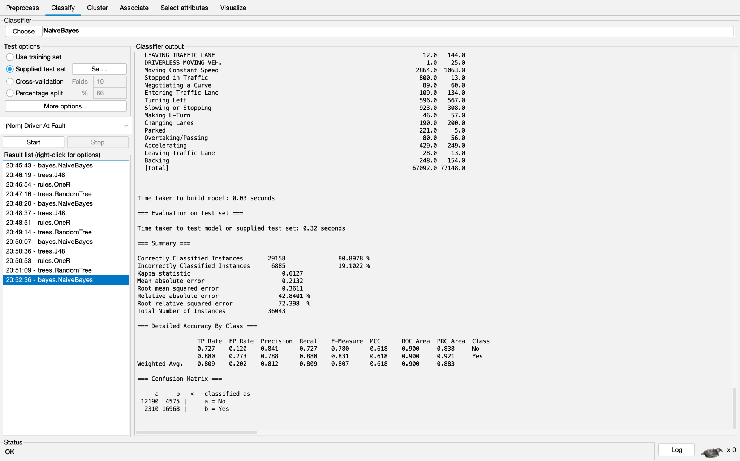

J48: OneREval

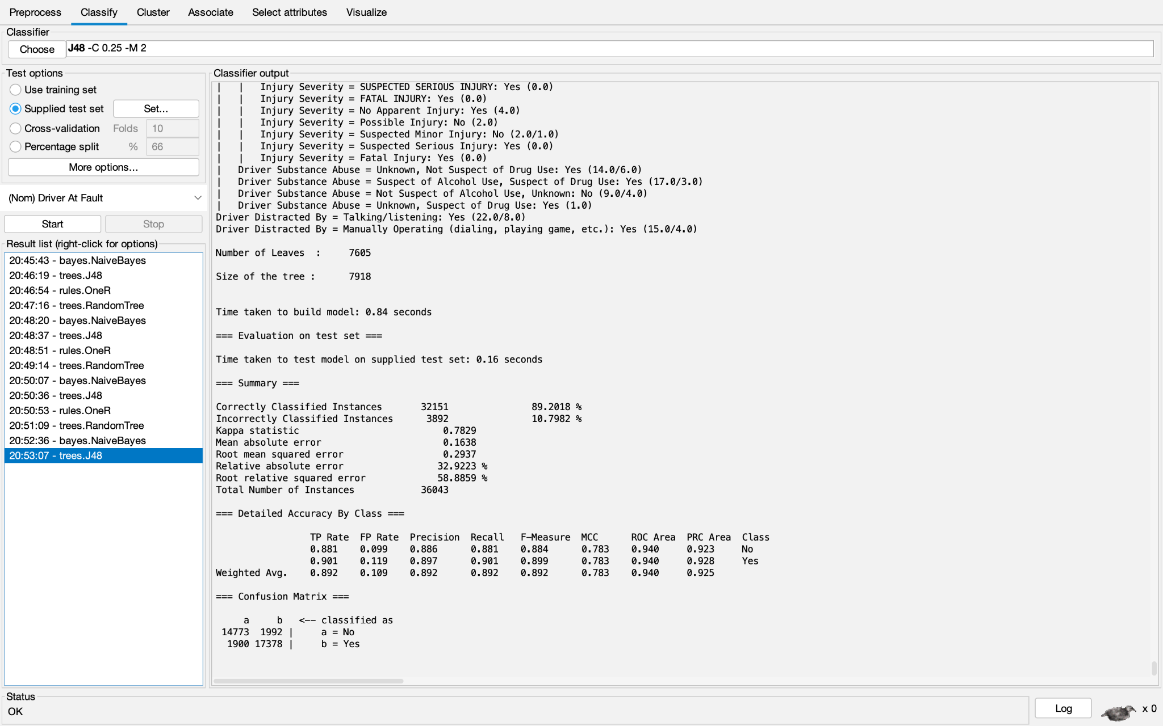

OneR: OneREval

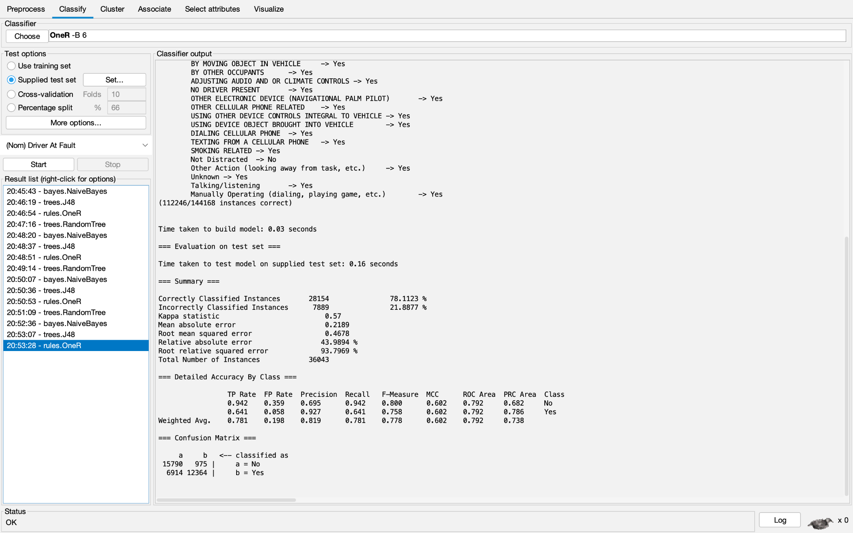

Random Tree: OneREval

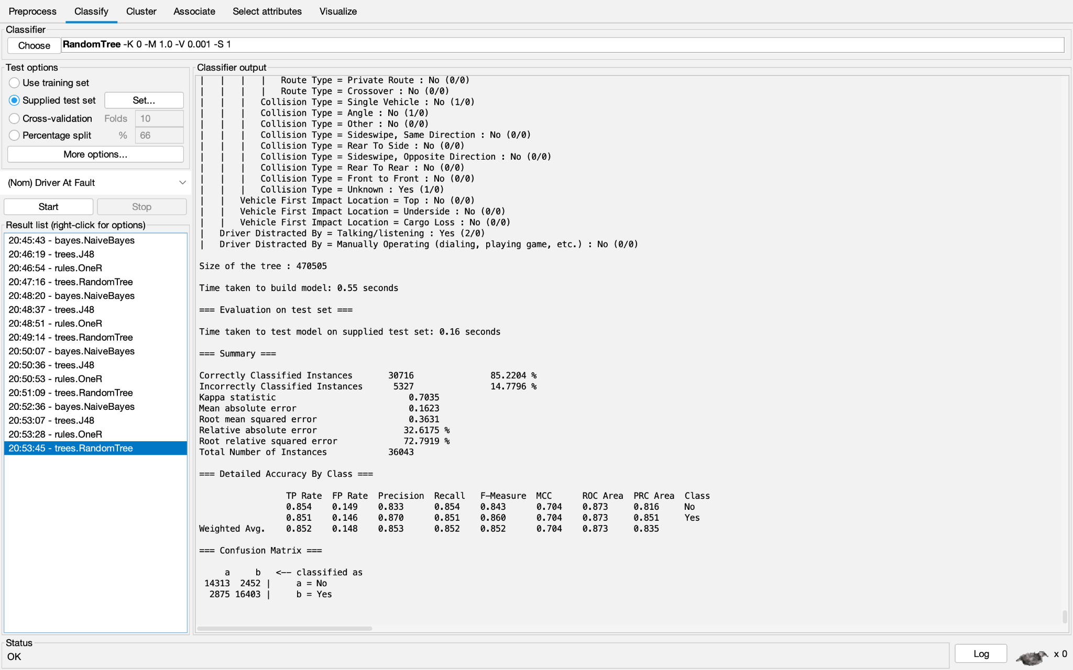

Naive Bayes: Self-Selected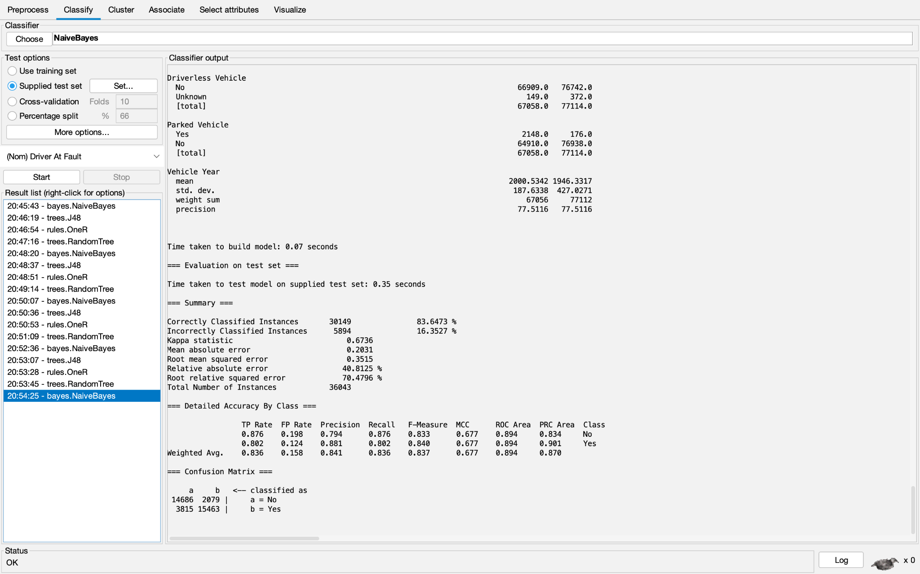

J48: Self-Selected

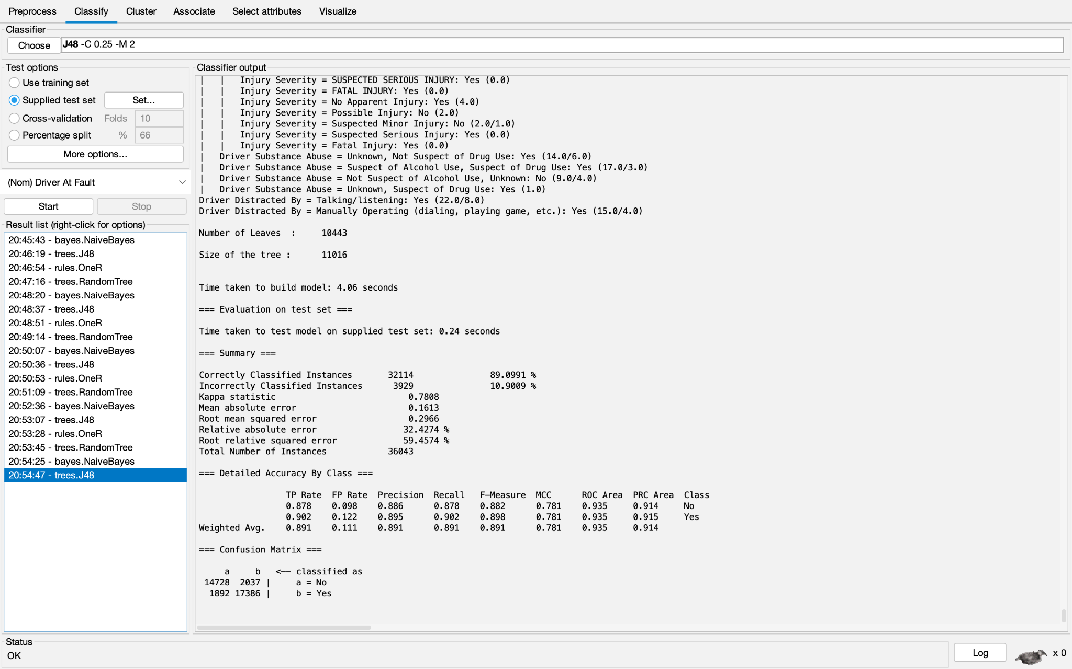

OneR: Self-Selected

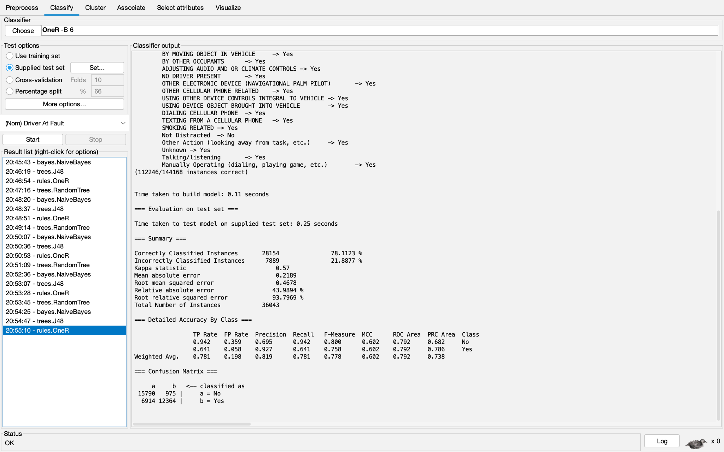

Random Tree: Self-Selected

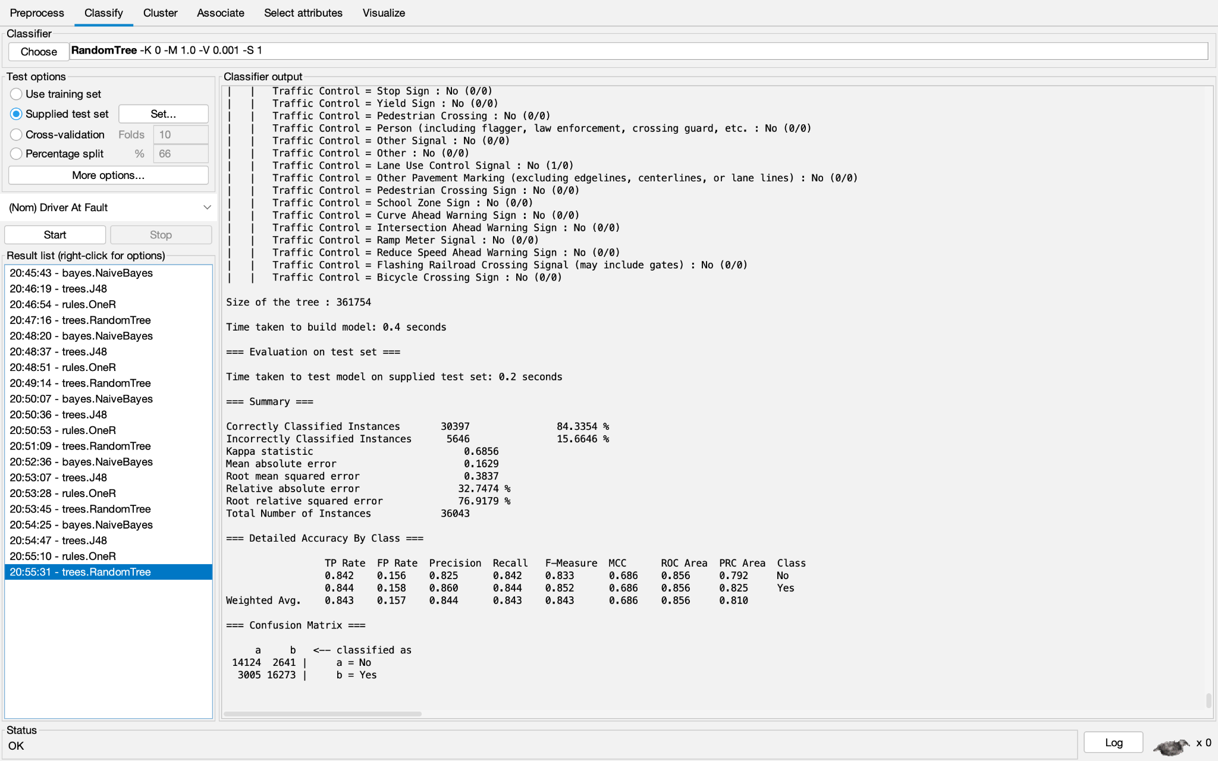

**Performance Metrics Used**

We determined that accuracy would be a good measure of performance for our models because our data had very little skew (56% yes, and 44% no) with only two classes. Additionally, we claim that other metrics of performance such as recall which are based on False Negative rates would not be very useful because the classes “Yes” and “No” are essentially symmetric. (For any use case of such a model, if the driver is not at fault, then the other party involved must be at fault. Thus, the consequences of false-negatives and false-positives are identical, so accuracy is the only important metric).

The J48 model with the InfoGainEval dataset had the best accuracy of 89%.

Highest TP Rate: 89.3%

Highest TN Rate:

Lowest Mean Squared Error: 0.264

This accuracy is decently high and provides decent prediction of who is at fault

**How to Reproduce**

1. Under the Preprocess tab, remove the attributes which prevent arff to csv conversion
2. Open Weka and load the “rawdata.csv” dataset.
3. Remove redundant attributes
4. Parse dates into only the minutes using the python code (code included on report)
5. Select the attributes according to the corresponding attribute selection algorithm.
6. Split the data into train and test splits.
7. Train the desired model (J48) using the test set as a “supplied test set”.
8. Click Start.